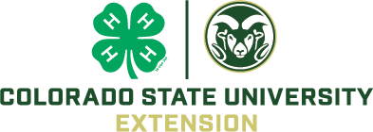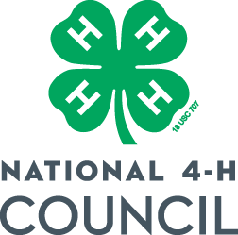

COLORADO 4-H LEADER AWARD APPLICATION – NATIONAL 4-H SALUTE TO EXCELLENCE
The national 4-H Salute to Excellence Volunteer Recognition Award recognizes 4-H volunteers who demonstrate exemplary service to 4-H, while promoting service through volunteerism as both an opportunity and a privilege.
In 2026, eight honorees will be selected. One volunteer will be selected from each Cooperative Extension Region in each of two categories. Each region will have its own Outstanding Lifetime Volunteer and Volunteer of the Year. The eight regional honorees become nominees for the national award, and one candidate in each category will be named the national Honoree. Please click here for more detailed information:
https://4-h.org/about/salute-excellence-awards/

Name: _______________________________________ County: _________________________
Address: _________________________________________________________________________
Phone (home & cell): ________________________________ Email: ________________________

_____ Outstanding Lifetime Volunteer (10 or more years of service to 4-H)
_____ Volunteer of the Year (less than 10 years of service to 4-H)

_______________________________________________________________________________________
Submit:
Letters of recommendation from Extension staff person, 4-H participant, another volunteer, or parent/guardian (three required).
Resume (limited to three pages, front only, 12-point font, 1 inch margins) Please provide the following information:
- Brief overview (500 words or less) of why volunteer deserves this award.

- Evidence of a positive impact on the lives of 4-H youth.
⋅ Demonstrated ability to work with young people in a way that promotes youth empowerment, decision-making, problem-solving, meeting challenges, and mastery.
⋅ Nominee’s dedication to youth/adult partnerships and developing mentor-learner relationships.

- Evidence of a positive impact on the 4-H program
⋅ Nominee’s innovative approaches to engaging new youth and increasing diversity among participants.
⋅ Dedicated to providing a safe and inclusive environment for youth.
⋅ Nominee’s innovative approaches to performing volunteer service, recruitment of additional 4-H volunteers, partnering with other youth serving agencies, fund raising, providing other resources for 4-H, advocacy of 4-H, etc.

- Personal attributes
⋅ Evidence of professional attitude, character, and morals.
⋅ Personal growth from being a 4-H volunteer (that you have observed).

- Personal involvement in 4-H
⋅ List local 4-H roles (4-H Project Leader, Community Club Leader, etc.) Include summary of years, roles, and organizations.
⋅ List County/District 4-H roles (County Extension Committee, advisor, etc.) Include summary of years, roles, and organizations.
⋅ List State/Regional/National 4-H roles (Regional 4-H volunteer Leader Forum Planning Committee, National 4-H Awards Selection Committee, etc.) Include summary of years, roles, and organizations.
⋅ List relevant 4-H honors/awards and years received.
⋅ List relevant non-4-H volunteer roles, Include summary of years, roles, and organizations.
- Optional/FOR INFORMATIONAL PURPOSES ONLY
⋅ 4-H involvement as a young person. Indicate the state where nominee was involved, type of involvement (4-H projects taken, 4-H camper, etc.) years of membership, exemplary awards, leadership roles, etc.
⋅ Current position (professional/homemaker). If retired, most recent role.

REQUIRED: Submit the completed application and a photo of the volunteer to Boulder4h@gmail.com by September 17, 2026.

6/8/2026

