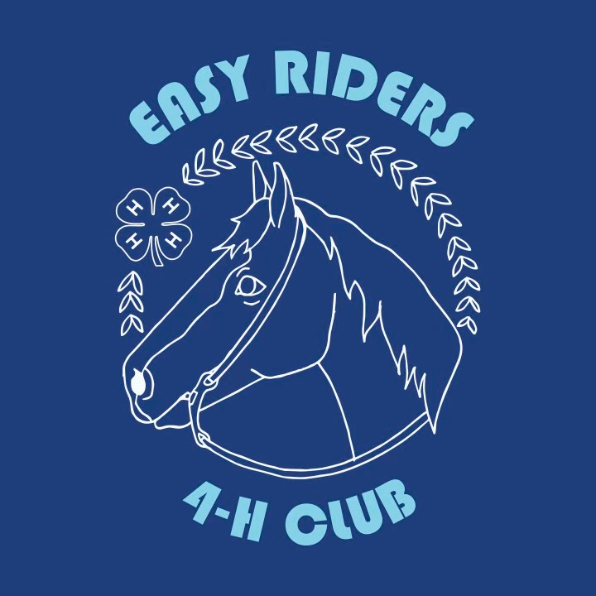
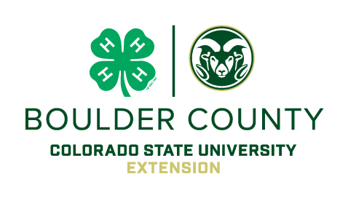
EASY RIDERS 50th Annual
4-H & OPEN HORSE SHOW
Sunday April 12th, 2026 9:00 am
Special Thank you to our sponsors!

Boulder County Fairgrounds Indoor Arena-9595 Nelson Rd, Longmont, Colorado
Judge: Maggie Murphy Show Manager: Kelly (303)506-6265

Entry Fee: $10.00 per class Office Fee: $10.00 per horse/rider Awards: Ribbons 1st – 5th place, placed through 6th Ribbon buy back-$1 per ribbon
**Qualifying Classes for Boulder County 4-H HLC Year End High Point Award**

ENTRY FORM – ONE HORSE/RIDER PAIR PER
BACK#:______ CLUB: ______________
RIDER: ___________________________
HORSE: _________________________ AGE(12/31/25):_____CELL#__________
EMAIL: _________________________
COUNTY: __________ Riding Level Passed
English _____ Western______

~SHOWMANSHIP Entries close at 8:45 a.m.~ New rule in 2025! Sms level=highest riding level
____1. OPEN SHOWMANSHIP:
____2. 4-H SHOWMANSHIP: Levels 3/4**
____3. 4-H SHOWMANSHIP: Level 2**
____4. 4-H SHOWMANSHIP: Level I**
____5. 4-H SHOWMANSHIP: Unrated**

~~ Short break for English warm-up in the Indoor Arena~~~
____6. OPEN ENG PLSR: rail
____7. 4-H/OPEN W/T ENG PLSR: rail**
____8. 4-H ENGLISH PLEASURE: Unrated, rail**
____9. 4-H/OPEN W/T ENG EQUITATION: rail**
____10. 4-H ENGLISH EQUITATION: Unrated, rail**
____11. 4-H ENG PLEASURE: Levels 3/4, rail**
____12. 4-H ENG EQ: Levels 3/4, pattern**
____13. 4-H ENGLISH PLEASURE: Level 2, rail**
____14. 4-H ENG EQ: Level 2, pattern**
____15. 4-H ENGLISH PLEASURE: Level 1, rail**
____16. 4-H ENG EQUITATION: Level 1, pattern**
____17. 4-H ENGLISH CONTROL: Levels 3/4 **
____18. 4-H ENGLISH CONTROL: Level 2 **
____19. 4-H ENGLISH CONTROL: Level I **
____20. OPEN & 4-H SHOW HACK LVL 2 & ABOVE**

~ LUNCH ~

Warm-up in the Arena before arena drag~
**** $5.00 TACO BAR LUNCH ****

___21. EGG & SPOON-OPEN FUN CLASS
____22. OPEN YTH WESTERN PLSR:rail
____23. OPEN ADULT WESTERN:HMS
____24. OPEN ADULT WESTERN PLSR: rail
____25. 4-H/ OPEN W/T WESTERN PLSR: rail
____26. 4-H WESTERN PLEASURE: Unrated, rail**
____27. 4-H & OPEN W/T WESTERN HMS.rail**
____28. 4-H WESTERN HMS: Unrated, rail **
____29. 4-H WESTERN PLEASURE: Level I, rail**
____30. 4-H WESTERN HMS: Level I, pattern **
____31. 4-H WESTERN PLEASURE: Level 2, rail**
____32. 4-H WESTERN HMS: Level 2, pattern **
____33. 4-H WEST PLSR: Levels 3/4 rail**
____34. 4-H WEST HMS: Levels 3/4, pattern **
____35. OPEN REINING
____36. 4-H REINING: Level I **
____37. 4-H REINING: Level 2 **
____38. 4-H REINING: Levels 3/4 **
____39. OPEN RANCH RIDING

~Short Break~OPEN YOUTH GYMKHANA

____42. POLES AGES 8-13
____43. POLES AGES 14-18
____44. KEYHOLE AGES 8-13
____45. KEYHOLE AGES 14-18
____46. FLAGS AGES 8-13
____47. FLAGS AGES 14-18
____48. BARRELS AGES 8-13
____49. BARRELS AGES 14-18

Please Read the Rules and Sign
Colorado & Boulder County 4-H Horse Show Rules Apply
~ In the 4-H classes, Exhibitors enrolled in a 4-H Horse Project show their own project horse(s) & compete at their current 4-H riding level
~There will be Boulder County 4-H HLC High Points awarded toward year-end high point awards for classes marked with (**). See County High Point Rules for details.
~ Helmets are REQUIRED for all Walk/Trot thru Level I Riders & recommended for all others.
~ Management may elect to combine classes with 3 or fewer entries or split classes with a lot of entries. ~ Barn C is available to use for riders/horses waiting between classes
~ Age as of December 31, 2025 and youth must be 8 years old to participate.
~ Open Youth classes are for ages 8-18.
~ Open Adult classes are for ages 19+
~ Proceeds from this show benefit the Easy Riders 4-H Club Youth
~ Riders in walk/trot/jog classes may not enter a class that canters/lopes ~ NO REFUNDS ON SCRATCHES-NO STALLIONS, NO DOGS IN THE INDOOR ARENA, 4-H SAFETY RULES ENFORCED.
NOTE: Please check Easy Riders Facebook page https://www.facebook.com/easyriders4h/notifications/ or contact show manager: Kelly Thomas (303)506-6265 or er4hclub@gmail.com for any updates or questions
WE ARE INCREDIBLY GRATEFUL TO OUR SPONSORS TO HELP MAKE THIS FUNDRAISING HORSE SHOW SUCCESSFUL FOR OUR YOUTH!
CASH/CHECK #/Name on check:_______/________________
#of Classes_____(x$10)________
Office fee($10):____________
Subtotal:________________
I would like to round up to the nearest $5 to support Easy Riders:_______(i.e.$34 goes to $35) Total:__________________
No Refunds will be given. Payment may be made via cash or check payable to Easy Riders 4-H Club when you arrive at the show or through Paypal: er4hclub@gmail.com .
YOUR ENTRY IS ACCEPTED SUBJECT TO THE AGREEMENTS BELOW:
I, the undersigned participant/guardian, exercising my own free choice to participate voluntarily in the above-named activities, and promising to take due care during such participation, hereby release and discharge, indemnify and hold harmless Boulder County, The Boulder County Fair Grounds, the Boulder County HLC, The Board of Governors of the Colorado State University System and Colorado State University, and their members, officers, agents, employees and any other persons or entities acting on their behalf, and the successors and assigns for any and all of the aforementioned persons and entities, against any and all claims, demands, and causes of action whatsoever, whether presently known or unknown, either in law or in equity, relating to injury, disability, death or other harm, to person or property or both, arising from my participation and/or presence at the above listed activities. Under Colorado law, an equine professional is not liable for an injury to or the death of a participant in equine activities resulting from the inherent risks of equine activities, pursuant to Colorado Revised Statutes.
Exhibitor Name: ______________________________________________________
Parent/Guardian Name (if under 18) _________________________________________________
Parent/ Guardian Name (if under 18) OR Exhibitor Signature:___________________
Extension programs are available to all without discrimination. An equal access and equal opportunity University. https://col.st/ll0t3

