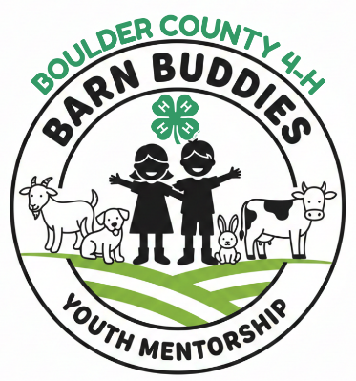

Boulder County 4-H Barn Buddies
Mentor Application- 4-H ages 11-18 only

Application is due by FEBRUARY 15, 2026
These Projects are offering the Barn Buddies Mentorship Program
Select which species you are applying to mentor another 4-H member:
___Rabbit ___Dairy Cattle ___Utility Goat ___Dog ___Dairy Goat

Criteria for Barn Buddies Mentorship Program: Please check each box that you agree or that you meet the qualifications:
- Must be an experienced 4-H Youth Member. Must be age 11 or older. Must have at least two years of experience in their specific animal project area (e.g., rabbit, dog, dairy cattle, dairy goats, utility goats).
- Must be recommended by their 4-H Club Leader, 4-H Superintendent, or 4-H Staff.
- Parent/Guardian Approval and Support
  - Parent/guardian permission and agreement to participate is mandatory. Parent/guardian must be aware of and approve the use of the animals for the program and be willing to oversee the mentorship and commitment.
- Commitment to mentoring 1-2 mentees over the year.
- Agreement to provide the necessary animal for the mentee to use during the special County Fair Showmanship Class.
- Agreement to attend Mentor Orientation.
- Agree to meet with 4-H mentee at a minimum of 6 times throughout the year. This can be done at a 4-H project workshop, at your home with parental supervision, or at other planned opportunities but must me a safe structured learning time.
- I agree to maintain the Mentor/Mentee Summary Log
- I agree to work with the species superintendent for guidance suggested training topics.

- Personal Information Response
Full Name
Email Address (youth if you have one)
Phone # (s)
Email Address- adult/guardian/family
Parent(s)/Guardian(s) Name
4-H or FFA/Club or Chapter Name  Years in 4/H or FFA | # of Yrs:
Number of years in Animal species- please list each

- Relevant Leadership Experience (not required, but helpful)
Organization | Leadership task | Details/favorite part

- Questions: Due with the application submittal.
Answer the following questions: (Use a separate paper)
- Why do you want to be a mentor for the barn buddies program?
__________________________________________________________________________
__________________________________________________________________________
__________________________________________________________________________

- What animals do you own that you would like to share with others? Explain the personalities of the animals?
__________________________________________________________________________
__________________________________________________________________________

- Describe what 4-H mentorship means to you? __________________________________________________________________________
__________________________________________________________________________

- What motivated you to apply to be a mentor for the barn buddies? __________________________________________________________________________
__________________________________________________________________________

- Two people who know your experience with your animals and would recommend you for this program. 4-H leader, superintendent, parent, breeder, member, etc.
1. Recommender’s Name  Relationship to Applicant |  | Email/phone:
2. Recommender’s Name  Relationship to Applicant |  | Email/phone:

- All applications must be received electronically by February 15th, 2026, for consideration.
- PLEASE email application and supporting documents to 4hinfo@bouldercounty.gov

I certify that all the information I have provided in this application is complete and correct to the best of my knowledge. As a parent/guardian I agree to support my member as they participate in the barn buddies mentorship program.
Signature | Date:
Parent Signature

End of application

