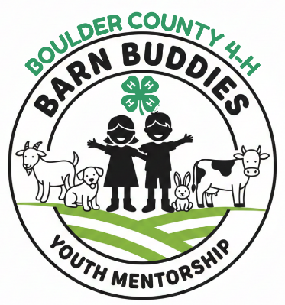

Boulder County 4-H Barn Buddies
Participant/Mentee Application – 4-H ages 8-18 only

Application is due by March 1, 2026

Criteria for Barn Buddies Mentorship Program: Please check each box that you agree or that you meet the qualifications:
- I agree to be an enrolled 4-H member in Boulder County 4-H, ages 8–18.
- I agree to enroll in the Discovering Animal Science 4-H Project.
- I agree to participate in a 4-H club and fully participate in 4-H club level activities.
- I have Parent/Guardian Approval and Support:
  - Parent/guardian permission and agreement to participate is mandatory. Parent/guardian must be aware of and approve working with animals for the program and be willing to oversee the learning and commitment.
- I commit to attend all scheduled mentor sessions (minimum of six) and communicate with volunteers and mentees families regularly.
- I agree to complete all 4-H project completion requirements, including the record book, display board, and exhibiting related to the Discovering Animal Science Project.
- I agree to meet with 4-H mentee at a minimum of 6 times throughout the year. This can be done at a 4-H project workshop, at your home with parental/adult supervision, or at other planned opportunities but must me a safe structured learning time.
- I agree to maintain the activity summary log
- I agree to work my assigned mentor, their animals and the species superintendent to learn.
- I agree to complete an end of program evaluation and skills survey.

- Personal Information Response
Full Name
Email Address (youth if you have one)
Phone # (s)
Email Address- adult/guardian/family
Parent(s)/Guardian(s) Name
4-H or FFA/Club or Chapter Name  Years in 4/H or FFA | # of Yrs:
4-H Projects (past and present):

These Projects are offering the 4-H Barn Buddies Mentorship Program in 2026. Please rank the species in order of your most desired level 1 to least desired 5. If you do not want to participate with a species, please put n/a next to that species.
___Rabbit ___Dairy Cattle ___Utility Goat ___Dog ___Dairy Goat

We will make every effort to accommodate all applications and member requests; however, participation cannot be guaranteed due to the availability of animals and mentors. If you are not selected this year, we encourage you to apply in future years.

- Current/past animal ownership: (No personal ownership of animals is required to participate.)
Animal | Details/how long/responsibility

- Questions: Due with the application submittal.
Answer the following questions: (Use a separate paper)
- Why do you want to be part of the barn buddies program?
__________________________________________________________________________
__________________________________________________________________________
__________________________________________________________________________

- What do you hope to gain from this experience?
__________________________________________________________________________
__________________________________________________________________________

- Do you have the ability to have animals at your home, please explain yes or no? __________________________________________________________________________
__________________________________________________________________________

- All applications must be received electronically by March 1, 2026, for consideration.
- PLEASE email application and supporting documents to 4hinfo@bouldercounty.gov

I certify that all the information I have provided in this application is complete and correct to the best of my knowledge. As a parent/guardian I agree to support my member as they participate in the barn buddies mentorship program.
Signature | Date:
Parent Signature

End of application

