**Traffic Direction for Goat/Lamb**

**Tag-in, Retinal Scan & Weigh-in**

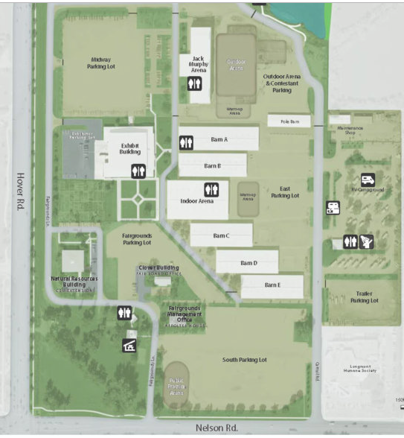

Mkt Goats and Lambs

**STOP TO TURN IN COMPLETE PAPERWORK**

**STOP TO GET PAPERWORK**

* Stop Outside of Barn C before entering and confirm your paperwork is complete (all except ear tags)
* Once Complete- pull in barn front

EAST TO WEST

* Tag-in is in Barn C
* 1 line formed (we will try for two lines divided by sheep/goat)
* Drive past the mid barn and pull to right or left (open/vacated area)
* Complete paperwork with staff, pay fee, and confirm entries prior to leaving fairgrounds.

**Lamb & Goats will have tag-in & retinal scan. Weigh-in is for every animal this year!**