Steps to Tag Market/Breeding Swine- Required Identification 2024- Boulder County
- YOU CAN COMPLETE THIS PROCESS IN ONE OF THREE WAYS
  - Self tagging and submitting photos and completed forms in 4HOnline by May 2nd.
OR
  - Come to in-person tag in with completed paperwork and we will tag your animals for you.
  - Setup a time with the 4-H County Specialist or 4-H Volunteer to have them come teach you how to tag. (On a schedule-available basis).

OPTION A: OR SELF TAGGING STEPS-on your own before 5/2/2024:
STEP 1
- PICK UP YOUR TAGS/SUPPLIES: Pay $4 per tag
- Come to the Extension Office to pay for your tags and pick up a tagging kit. You can call ahead of time to be sure there is one available. (303-678-6238) (Available starting April 2nd, 2024)
  - Please note: it is important that you pick up the tagger and tag your animals and return the taggers the following day. The tags are "AllFlex" tags so if you have your own tagger you do not need to borrow our taggers. This will only work if each of you do your part. Thank you for being responsible.
  - There will be disinfectant to spray on your taggers BEFORE and AFTER USE. Please utilize this on the equipment before returning to the Extension Office.
- Tag your animals in the Right ear– return tagging items quickly to the Extension Office so next person can use them.
  - Here is a fact sheet if you need some guidance on tagging correctly. http://pods.dasnr.okstate.edu/docushare/dsweb/Get/Document-6215/ANSI-3287pod.pdf
  - Here is a video on using an AllFlex tagger (time 3:22-4:36 ) https://www.youtube.com/watch?v=cIPbDQyxKWw
- Be sure to return tagging supplies to the Extension Office by the next day so the next member can use.
STEP 2
- Print the SWINE NOMINATION FORM attached to this email and on the website. Print the form for each exhibitor. (We use the Colorado State Fair Nomination form for Boulder County Nominations.)
- Look at each of your hogs and complete the drawing of each ear notches on the back of the form. FOR EACH ANIMAL, MAKE SURE YOU WRITE THE BCF TAG # correctly.
- Next Steps of Self tagging are to take photos of your pigs:
  - Right Side profile picture of whole animal
  - Left Side Profile picture of whole animal
  - Photo of Right Ear notches (BCF Fair tag should be also in this photo) (Place a piece of white paper behind ear to help ear notches show up clearly.)
  - Photo of Left Ear Notches (Place a piece of white paper behind ear to help ear notches show up clearly.)
  - Front View of pig
  - Exhibitors must be in at least one photo with each pig.

STEP 3
- Upload photos and pdf form into 4HOnline at https://v2.4honline.com Before 5/2/2024
  - Gather photos and PDF of the nomination form into one place on your computer and go through the Animal ID Process through 4HOline.
  - Create A PDF of your nomination forms- both sides. (Genius Scan is a free app on phones to create pdf scans)
  - Animal Id Directions can be found on the animal ID website: https://boulder.extension.colostate.edu/4h/animalid/
    - Log-in to 4HOnline using your family email.
    - Go to the Member and click “View”
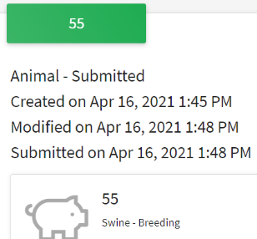
    - On the left side there is a list with “Animals”- click animals
    - Click “Add an Animal”
    - Click “Add New Animal” – complete info and “Next”
    - Click “Show Questions”
    - Add attachments (State Fair Nomination Form (We use for county Fair) and 5 photos.
    - Click on “Next”.
    - Review information and then be sure to “SUBMIT”
    - Take a screenshot/pdf of the page to prove your submission of the animal by the deadline.

OPTION B: ATTEND TAG IN AT THE FAIRGROUNDS IN-PERSON ON 5/6/2024 along with sheep and goats
- Sign up for a scheduled time for the in-person tag in at the fairgrounds by going to this link: http://tinyurl.com/bocoswinetag2024
  - Complete this by May 2, 2024
- Complete the Colorado State Fair Nomination form- two-sided prior to coming to the fairgrounds. We use this for the Boulder County nomination as well and ALL MEMBERS MUST COMPLETE.
  - Form can be in the email or on the website under Swine Nomination form
- Bring $4 per animal you are tagging (Checks payable to Boulder County Extension or exact cash appreciated)
- We will have your tags at the event and no need to pick them up ahead of time.

A Great Video for Reference on ear notches:
https://surechamp.com/blog/2016/06/29/how-to-read-pig-ear-notches/
Please Draw the ear notches while looking at your pig’s ear.
(Do not go off of paperwork provided to you.)
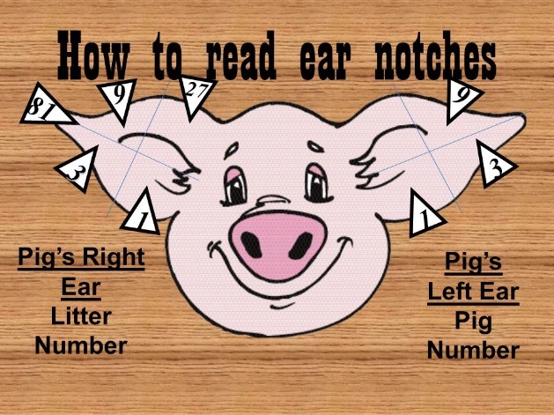

Here are some example photos:

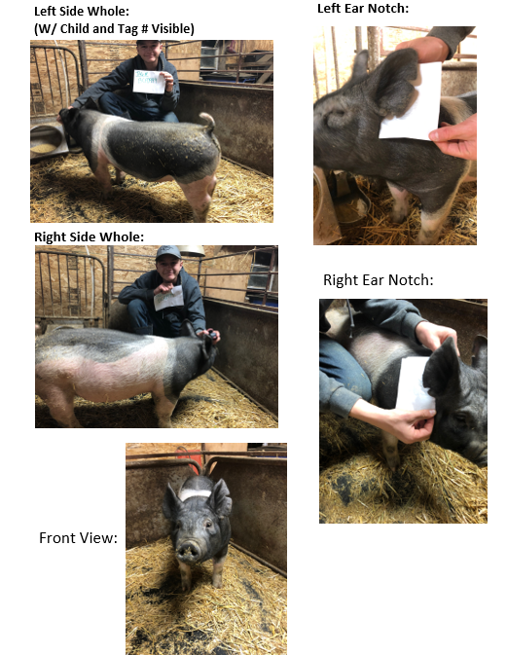

If you have questions about your animal IDs contact Lisa Wallace at the Extension Office by email lwallace@bouldercounty.org. It is your responsibility to be sure they are identified correctly.

