4-H Online 2.0 Animal Entry Guide
Boulder 4-H Goat Projects (Breeding, Dairy, Fiber and Utility)

- Deadline the last Thursday In April annually
*Note: For 4-H Members 8 and above

Gather the following items for your Animals:
- Two Photos- Right Side profile, Left Side profile- JPEG
- Premise ID where your animal is kept
- Scrapie Tag/Flock ID number OR
Registration papers(from Breed association if applicable) – PDF
- Identifying information including, name, tag/tattoo, registration numbers, birthdate, etc.
  - For Tattoo/Tag- you can use name and tattoo or just name of animal if no tattoo

Log into 4-H Online

- Use your family email and password https://V2.4HOnline.com

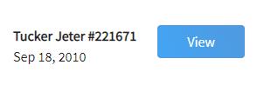
Click “View”, next to Member’s Name

Locating ‘Animals’

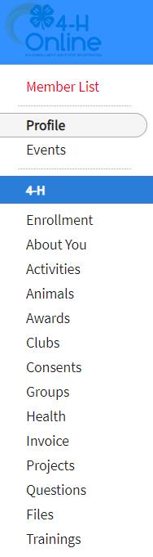
- Desktop, select “Animals” from the left side navigation

- Smart Phone or Tablet, click on the 3 bars in the top left corner
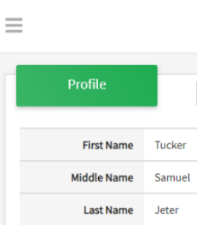
With either option, this will bring up a drop down list to begin adding Animals.

Adding an Animal
- Click "Add an Animal"
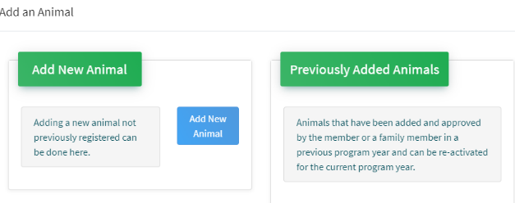Then select “Add New Animal”
- Select Goat- Meat Breeding, Goat- Dairy Breeding, Goat-Fiber or Goat- Utility from the drop down. REQUIRED: Enter Tag OR Tattoo Number. NOTE: Required Field is different between breeding or market animals. If an animal does not a county number enter 000. Click “Save”
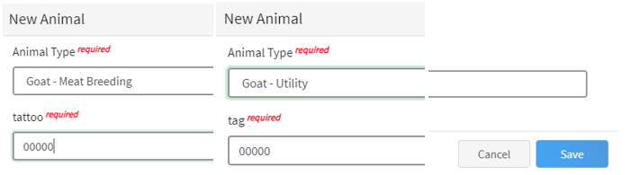
- Next, click “Show Questions”
Animal Entry is open for the current enrollment year. - Is all information complete? Check all county animal entry deadlines.
READ All County instructions for each animal species as county requirements vary.
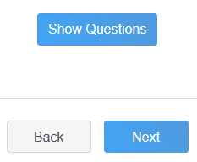

- For Breeding Goat, Fiber Goat or Utility Goat was weighed in at an official tag in/weigh in use that weight, enter the beginning weight of the animal. Otherwise use the weight of the animal at the time you purchased or if home-raised, when it was born. Enter, if applicable for the animal.
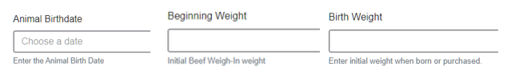
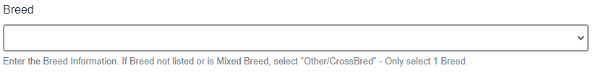
- Choose the breed from the drop down box. Choose *Other/Cross Breed or Mixed Breed. You can only choose one breed.

- Enter any distinguishing colors or markings.
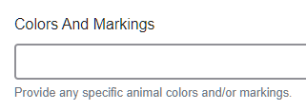
- Add Premises ID or Location ID, as this is needed for the Boulder County Fair- Please complete.
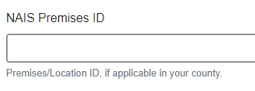
- Enter the Scrapie Flock ID, if applicable.
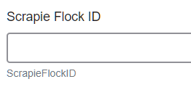
- Select the animal gender from the drop down box.

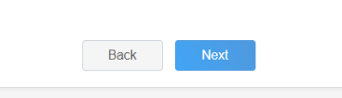
- The tag OR tattoo number entered on the first screen will carry over to this screen. Please verify that they tag number is correct for the animal entered above.
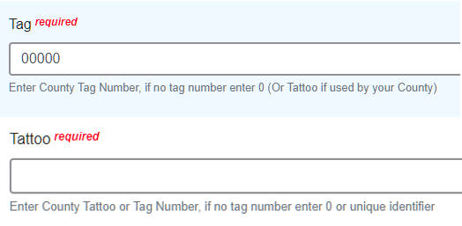

- Click “Next”, continue with the “File Uploads” that are required by your county. Boulder County needs two photos of your goats- one of each side profile- left and right side. You also should upload your registration papers here.
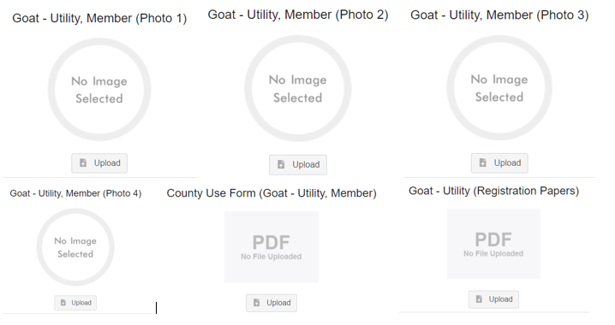
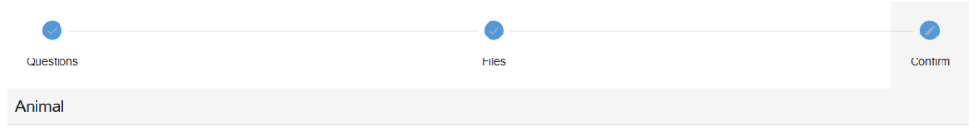
- Confirm all information,
Click ‘submit’
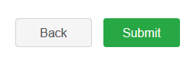
- County Extention staff, will review all information. If more is needed, members can edit. Once “Approved” by your local county extension office an email will be sent to your family account (example below) A time and date stamp for each animal.
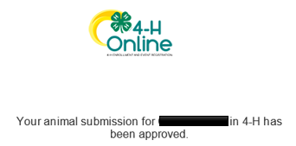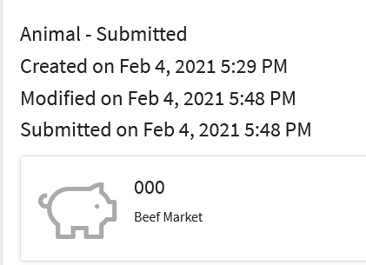

- Questions, please contact the Boulder County 4-H Office staff,
Lisa Wallace, lwallace@bouldercounty.org.

