4-H Online 2.0 Animal Entry Guide
Dog Project- Boulder County- Deadline the last Friday In April annually *Note: For 4-H Members 8 and above

Gather the following items for your Animals:
- Two Side Profile Photo- Show entire dog - JPEG
- a scanned copy of your dog's shot record showing current vaccines for Parvo, Distemper and Rabies- PDF
- a scanned copy of your dog's Rabies Certificate (the one with the vet's signature on it)- PDF
- your dog's weight and height as measured at the withers
- Identifying information including, name, registration numbers, birthdate, etc.
- For the vaccination dates, you will enter the DUE DATE for your pup's next booster shot (the form incorrectly references Expiration Dates)
- The Registration Number is a required field. If your pup is not registered with AKC or UKC, you can enter any combination of numbers to bypass this field.
- You can skip over the field for Tag #. (or put the dogs name again)
- The County Use Form is NOT required for dogs, so you can skip that upload

Log into 4-H Online

- Use your family email and password https://V2.4HOnline.com

Click “View”, next to Member’s Name

Locating ‘Animals’

- Desktop, select “Animals” from the left side navigation

- Smart Phone or Tablet, click on the 3 bars in the top left corner
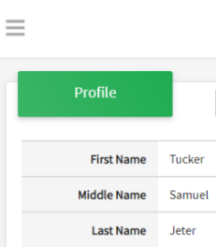
With either option, this will bring up a drop down list to begin adding Animals.

Adding an Animal
- Click "Add an Animal"
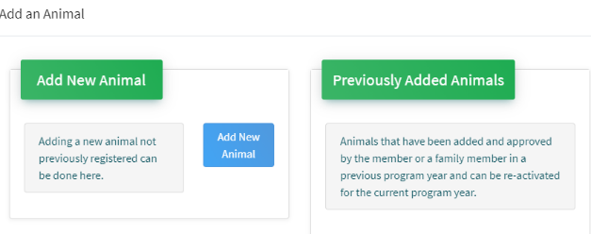Then select “Add New Animal”
- Select Dog, from the drop down. REQUIRED: Enter Animal’s name, click “Save”
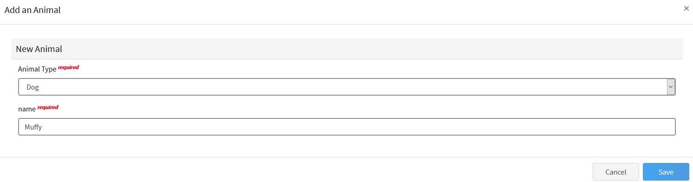
- Next, click “Show Questions”
Animal Entry is open for the current enrollment year. - Is all information complete? Check all county animal entry deadlines.
READ All County instructions for each animal species as county requirements vary.
- The animal’s name will be carried over from the previous screen.
- Enter the CURRENT weight of the animal. This is for determining size of the animal.
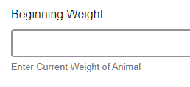
- Enter the animal’s birth date.
- Choose the breed from the drop-down box. Choose “other breed” or “mixed breed” if breed isn’t listed. ONLY select one breed.

- Fill in a description of the dog’s colors and markings.
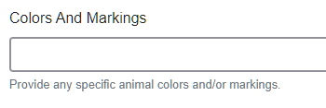
- Enter the dog’s height in inches as measured from the ground to withers (highest point of the dog’s shoulders).
- Enter whether you own the dog or are leasing it.

- Enter all vaccination information (Note: Enter Expiration dates) 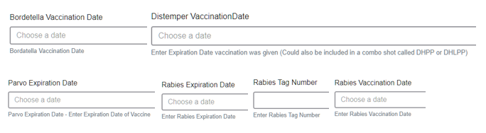
- Enter the registration information if your dog is registered.

- Enter the Animal Gender – male or female.

- Enter a Tag or Tattoo, if applicable.
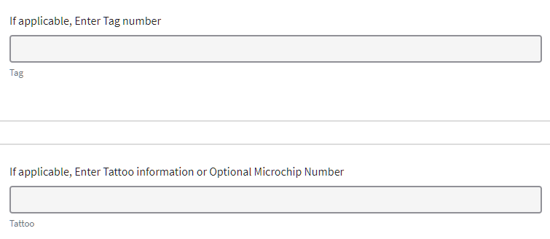

- Click “Next”, continue with the “File Uploads” that are required by your local county extension office. These will vary by county and species. Please follow your county guidelines. Boulder County- 1 clear photo of the dog showing entire body.
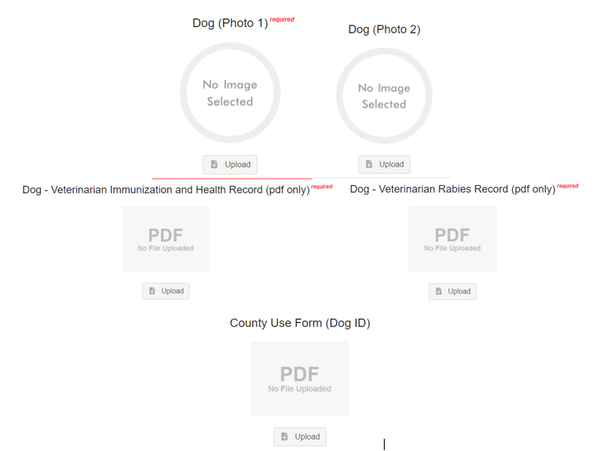
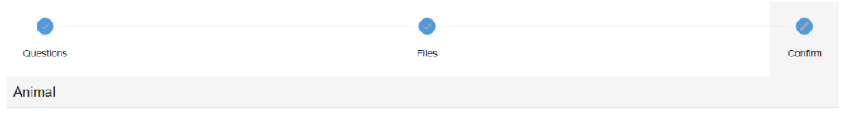
- Confirm all information, click ‘submit’
- County Extention staff, will review all information. If more is needed, members can edit. Once “Approved” by your local county extension office an email will be sent to your family account (example below) A time and date stamp for each animal.
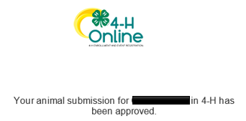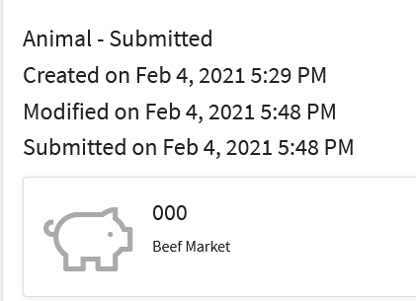
- Questions, please contact the Boulder County 4-H Office staff,
Lisa Wallace, lwallace@bouldercounty.org.

