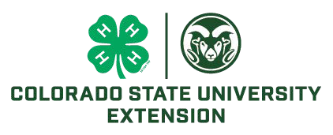
Individual Nomination
Team Nomination

BOULDER COUNTY, COLORADO 4-H VOLUNTEER AWARD APPLICATION
OUTSTANDING DISTRICT/STATE VOLUNTEER

This award is for volunteers who have been involved in the District/State level and getting youth involved in District/State level

Name County

Address

Phone (home & cell) Email

Club/Group Name Number of Club/Group members

Role in County:
Organizational Leader Project Leader
Other, please specify

Submit:

______Letter of support from a 4-H member or leader (1 required)

How does this person promote 4-H as a whole?

How many club/group members participate in county events?

How many club/group members participate in district events?

How involved is this person in state and/or national events?

What is this person’s involvement in planning and implementing club/group activities?

Give an example of how this person serves as a role model for positive youth development.

Does this person have the ability to work with both adults and youth (at every level)?

Signature: Date:

Agent Signature: Date:

Please submit applications to boulder4h@gmail.com by September 15, 2023.

8/21/2023

