- Horses/ponies/teams will be shown at a walk, park gait, road gait flat-footed walk, a working/road trot and an extended trot both ways of the ring. Horses/ponies/teams should stand quietly and back readily.

- Members must pass the Boulder County driving safety test performed by any approved state 4-H horse rater prior to the fair entry deadline. (This test can be performed by any state 4-H horse rater and does not have to be a rater outside of your club.)

- To be judged on the individual and collective response of the animal(s) to the driver’s verbal and manual signals, ability of driver, the ease with which he/she puts the animal(s) through their paces and their response, and the working relationship between the driver and animal(s).

- An adult (18 or over) must accompany any 4-H members under 18 in the vehicle at all times, but should not take the reins unless necessary to control the horse/pony/team or to prevent an accident, or to warm up before the start of the actual class. Vehicle should have appropriate room for two. No one other than the designated adult and 4-H member may be in the vehicle at any time. For carts driven by miniature horses only, the attending adult may instead: Walk into the arena beside the cart, staying with it until the class begins. At that point, the adult will move to the center of the arena while continuing to monitor his/her cart. The adult will return to the side of the cart for arena exit. This is not an option for carts pulled by any horse larger than a mini.

- It is the responsibility of each competitor to ensure that harness and vehicle are in good repair and structurally sound. No stirrup-type carts or sulkies will be allowed.

- Equipment to be used: a collar or breast collar harness, a standard bridle and a snaffle or curb bit. If using a curb bit, the curb chain must meet the judge’s approval. The curb chain must lie flat against the jaw and must be at least ½” in width. Check reins, martingales, a whip suitable to vehicle, nosebands, or blinkers may be used at the exhibitor’s option. No wire curb straps, padded or covered, or any other artificial appliances will be allowed.

- The exhibitor shall be neatly attired. The basic driver’s outfit calls for a conservative pant or skirt, a hat, sturdy shoes or boots, and if wearing a short skirt, an apron or lap robe (gloves are optional). English or Western show attire may be worn.

- Under no conditions should a bridle be removed from horse while the horse is still hitched to a vehicle.

- Horse/ponies/teams should never be left unattended while hitched.

- A driver should never allow passengers to enter a vehicle until the driver is seated with reins in hand and must never exit the vehicle while passengers are in the vehicle.

- The judge must excuse from competition an unsafe vehicle or any unruly horse/pony/team. Drivers should remain a safe distance from other vehicles. Any driver endangering the safety of other participants and unable to control his/her horse/pony/team will be disqualified. A vehicle/harness inspection may be held prior to class entry.

- Parade or silver equipment is permitted but shall not count over normal working equipment.

- Change of direction shall be accomplished by the entries walking across the diagonal at the direction of the ring steward.

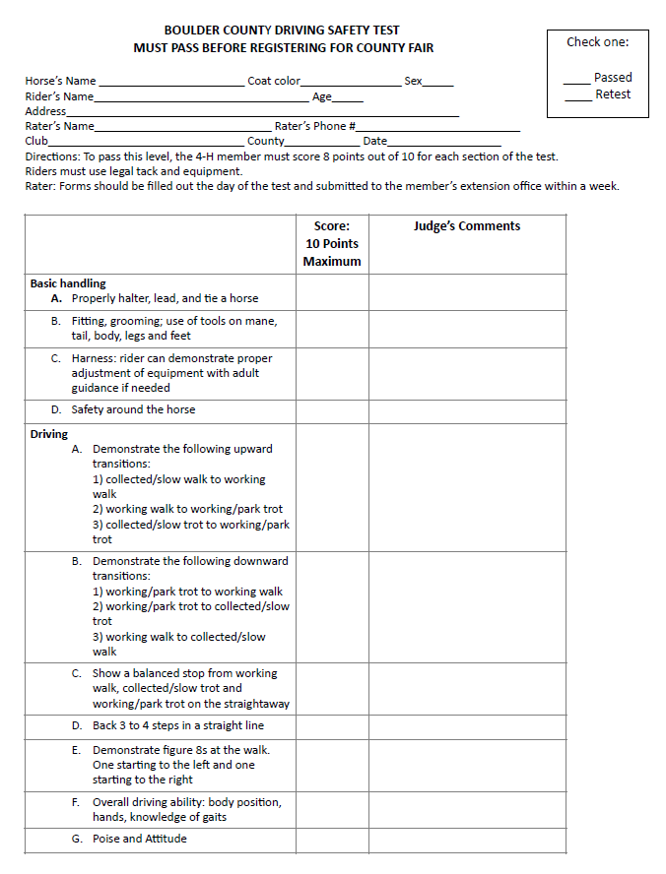

DRIVING SAFETY TEST – ATTACHED

