BOULDER County Family Exhibitor Entry
Important Reminders
- Deadline for most entries for the Boulder County Fair is July 14th. Be sure to complete your entries (including the final “Submit” step) prior to the cut-off date. There are NO LATE ENTRIES in 2022.
- Register ALL entries for each exhibitor in the family before proceeding to the Payment section. If you submit one family member’s entries it will lock the system until our office approves the entries. Plan ahead!
- Be sure to click the “Submit” button when you have completed your entries. Entries are not final until they have been submitted.
- Check your email inbox for a confirmation email with a list of your entries and any related fees. If you don’t get an email, contact our office to confirm.
- You will receive a second email when your entries have been approved by your fair or show.

- You may access the Boulder County Fair at:
https://fairentry.com/Fair/SignIn/16724

- Using your 4HOnline family account, select to “Sign in with 4HOnline” and enter your login information.  NOTE: If you forgot your password for your 4HOnline account, you will need to go to 4HOnline (http://v2.4honline.com ) to set a new password. Then use the new password (not the temporary password) to log in to FairEntry. |  | 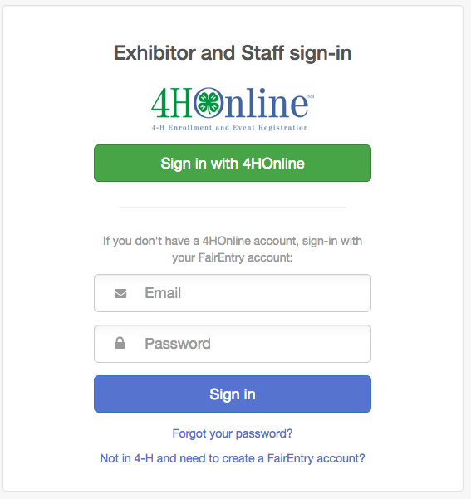
- Click “Begin Registration” |  | 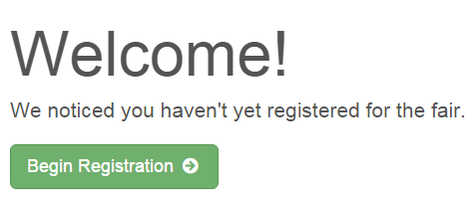
Exhibitor Information  If your fair is configured to accept both individual and team entries, click on the appropriate choice for your entry. Some fairs may only be configured for individual entries. |  | 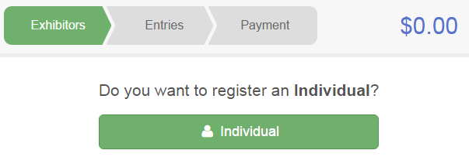
- Select the radio button for exhibitor in your family. Selecting 1 exhibitor at a time. |  | 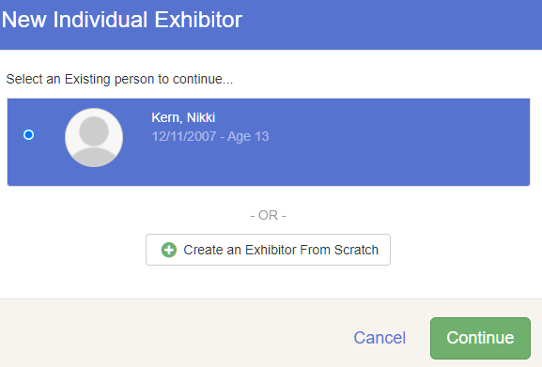
- If your fair or show asks additional questions, Answer any questions, and click Continue.

If your fair requires you to upload any files for the exhibitor, those will be later in the process. Upload requested files, and click Continue.
Review the exhibitor information. If any information is incorrect, click the green Edit button in the appropriate group to change it. When all information is correct, click Continue to Entries. |  | 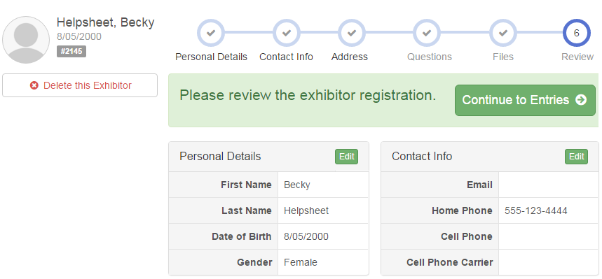
Creating Entries
Each exhibitor can have multiple entries. One entry must be made for each item, animal, class, etc. For example, if an exhibitor is bringing 2 photographs, two entries into the photography class must be created. If an exhibitor is showing one horse in 5 events, five class entries must be created. Once all entries have been created for the first exhibitor, you have the choice of creating another exhibitor in this exhibitor group (and entries) or proceeding to check-out (submitting the entries, whether or not fees are charged).

- Click Add an Entry beside the correct exhibitor (if more than one has been created). |  | 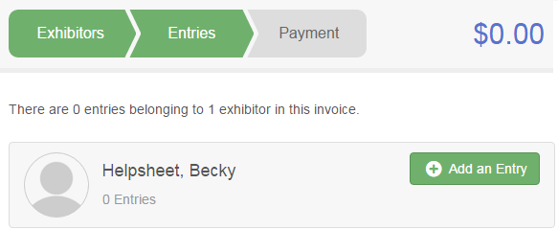
- Click Select beside the first department you wish to enter. Any departments that are not available for entry will be noted as “Not Available” with a short explanation.  - After you select a department, you will see a list of divisions to select from, and then a list of available classes. Also notice that there are blue “Change” links in case you mistakenly select an incorrect department, division, or class.  - After you have selected the class, click the green Choose button. |  | 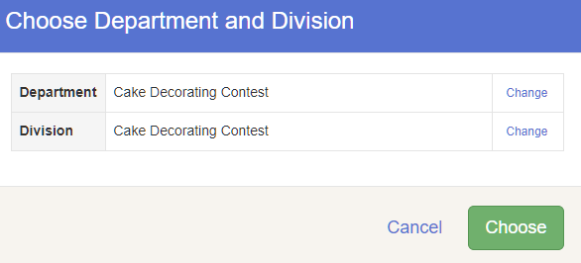
Single Entry Process
- Select the class you in which you will be participating. Click Select and Save the entry.  - If you are prompted to select your Club, click the radio button and click Continue. | 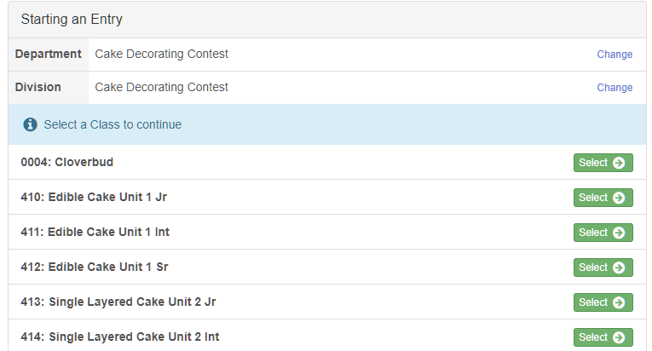
- Enter a detailed description for the project, if required  - Click Continue. | 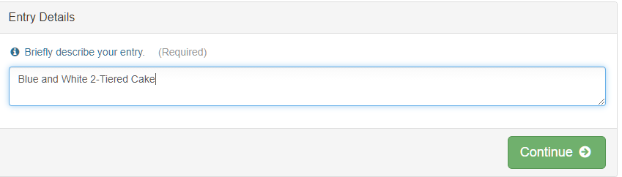
- If required in your county fair, upload any files.
- When each class entry is complete, you have three choices for what to do next:  - If all class entries have been completed for one exhibitor, you can Register another Exhibitor in this exhibitor group.  - If this exhibitor has more class entries to make, you can Add another Entry for this Exhibitor.  If all entries for all exhibitors in the exhibitor group have been completed, Continue to Payment to finalize and submit your entries. | 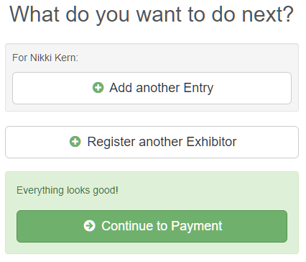
- Review your entries for completeness and accuracy. Notice the Summary and Detail buttons at the top of the list on the right. If there are errors, click on the green Entries section at the top of the page. Click Continue when all information is correct.  - Once all entries have been entered for exhibitors in your family, “click agree” to terms and conditions and submit the invoice for approval.  - You will receive an email message when the entries have been submitted for approval. You will receive a second email when the entries have been approved. | 