Traffic Direction for Goat/Lamb
Tag-in, Retinal Scan & Weigh-in

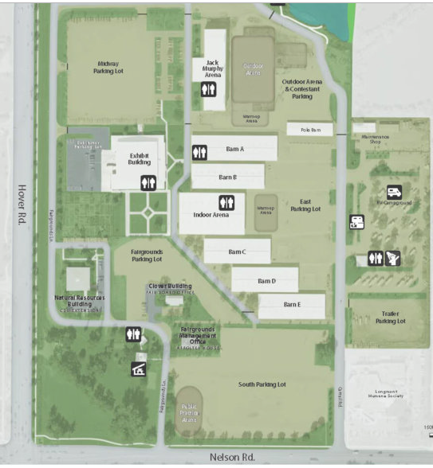
Mkt Goats and Lambs
- Stop Outside of Barn C and confirm your paperwork is complete
- Once Complete- pull in barn
- Tag-in is in Barn C
- 1 line formed
- Drive past the mid barn and pull to right or left (open/vacated area)
- Complete paperwork with staff prior to leaving fairgrounds.
EXIT

Lamb & Goats will have tag-in & retinal scan. Weigh-in is for every animal this year!

