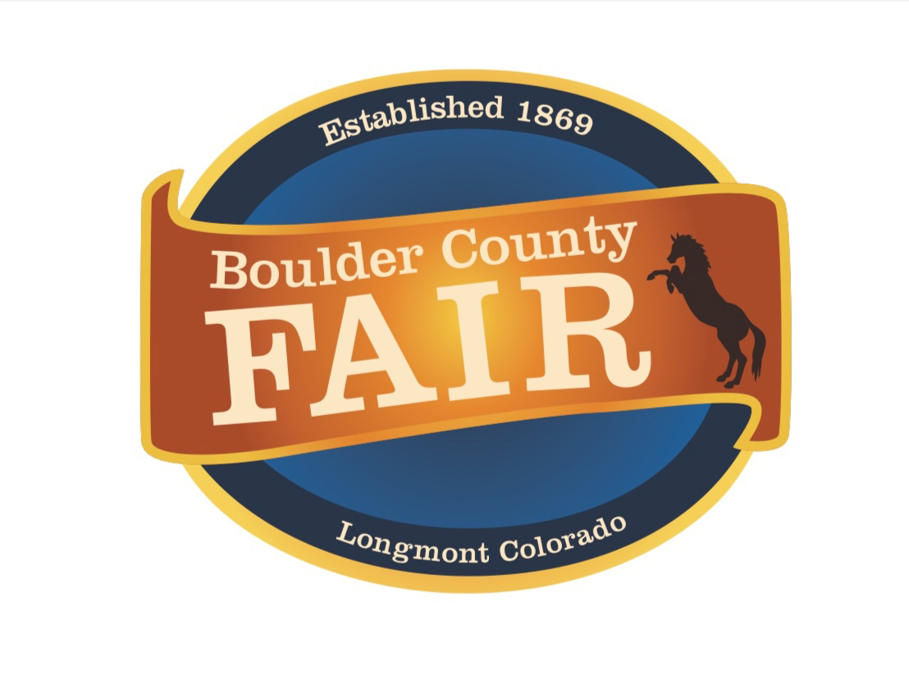

Boulder County Fair Jr. Livestock Sale Committee
Scholarship Requirements

- Must have sold a project in the Boulder County Fair Jr. Livestock Sale for three (3) years.

- Must be a high school senior or a full time student at a credible Jr./Community College or University.

- Must have a minimum GPA of 2.5

- Must complete the scholarship application and submit with supporting documents to jrlivestocksale.bcf@gmail.com by May 1st.

- Must provide the most recent high school or college transcript.

- An interview may be requested.

- One (1) $1,000 Jerry Hergenreder Memorial Scholarship will be awarded (essay required). Additional general scholarships will be awarded at committee discretion.

- Awarded scholarships will be mailed directly to the college/university that the applicant is planning to attend.

- Scholarship must be used within one year of receiving the award.

Boulder County Fair Jr. Livestock Sale Committee
Scholarship Application

Applicants Name:___________________________________________________________________________________________

Mailing Address:____________________________________________________________________________________________

_________________________________________________________________________________________________________________

Email:_______________________________________________ Phone #:_____________________________________________

Parents Name(s):___________________________________________________________________________________________

Applicant Type (circle one): 4-H or FFA

Club or Chapter Name:_____________________________________________________________________________________

Educational Background:
Name of School Dates of Attendance

____________________________________________ ________________________________________________

____________________________________________ ________________________________________________

GPA:___________________ # of Semesters determining GPA:________________________________

College plan on attending:_________________________________________________________________________________

City & State of College:______________________________________________________________________________________

Major Course of Study:______________________________________________________________________________________

Year in College this fall:_____________________________________________________________________________________

Number of years sold project in Boulder County Fair Jr. Livestock Sale:___________________________

Projects Sold at Boulder County Fair Jr. Livestock Sale:_______________________________________________

__________________________________________________________________________________________________________________

Number of years as a member in Boulder County 4-H/ FFA:__________________________________________

Additional Application Requirements:

-Provide a list of 4-H/FFA activities

-Provide a list of accomplishments and memberships

-Provide a list of community activities

-Optional*** Provide an essay for consideration for the Jerry Hergenreder Memorial Scholarship.
In less than 500 words, how has being a member of 4-H or FFA allowed you to grow as a person?

-Please email completed application and supporting documents to jrlivestocksale.bcf@gmail.com

