Beef Tag In Directions- UPDATED 3/27
2021 BOULDER COUNTY FAIR- 4-H and FFA Members
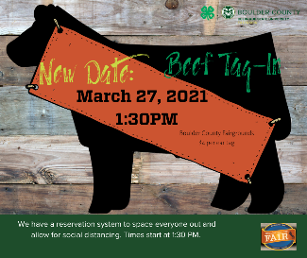
We will be tagging and identifying market beef projects on Saturday, March 27th, 2021 (new date due to snow) at the Boulder County Fairgrounds- Barn C. Animals must be halter broken and have a halter on to smoothly go through the identification process. We are limited to the number of people on the fairgrounds due to Boulder County policies for activities during COVID times. Please sign up for a time spot on the signup genius found here: https://tinyurl.com/y4p8fyrm We are requesting only the beef member(s) and one adult helper per family will be allowed in the scale area according to keeping the numbers of 10 per area.
Please review the available slots and click on the button to sign up. Please select one slot per trailer up to 3 head of cattle. If you have more than three head, you must select another adjacent time spot. Example: 7 steers in one trailer = 45 minutes reserved together. Sign up with your full name and the number of animals. Please be on time for your chosen timeslot. Members who are late will be accommodated as possible (you may have to wait.)

Listed below are some simple check list steps to be sure you are prepared and ready for the day.

Ahead of time steps to be prepared for beef tag in:
- Sign up for a time for tag day https://tinyurl.com/y4p8fyrm
- Obtain a brand inspection of your animals IN THE 4-H MEMBER’S NAME. Even if the animal was born on your property, you need to have a brand inspector write a brand paper for you in your 4-H member’s name (not a parent’s name)
- Obtain completed breed verification forms if you are showing a purebred animal. These need to be signed from your breeder,
- Download and print “State Fair Nomination Form” that we use for ALL BOULDER COUNTY Market Beef- complete this form. https://boulder.extension.colostate.edu/4h/livestock/beef/
- Get a Colorado Premise Identification number (LID#) where your animal lives. Each member must have a Premise identification number or Colorado Location Identification Number to participate in the Boulder County Fair. This is the location where your animal is housed. Obtain a premise ID or call 303-869-9130.

For More Information or Questions about the Beef Project contact:
Jenea DeQuasie- Beef Superintendent - Jnjdeq9@aol.com
John Herring – Assistant Beef Superintendent - outdrilling@gmail.com
Brenda Kwang- 4-H Extension Agent, Livestock – bkwang@bouldercounty.org
Lisa Wallace, 4-H Program Assistant for Extension Office – Helps with Animal ID process- lwallace@bouldercounty.org

More resources can be found here:
https://boulder.extension.colostate.edu/4h/livestock/beef/

Day of Beef Tag in – Steps for 4-H Families
- Bring your Brand Papers, completed breed verification forms, and State Fair nomination form (also used for Boulder County).
- Bring $4 per animal for tag fee. (Exact cash is appreciated- no credit/debit.)
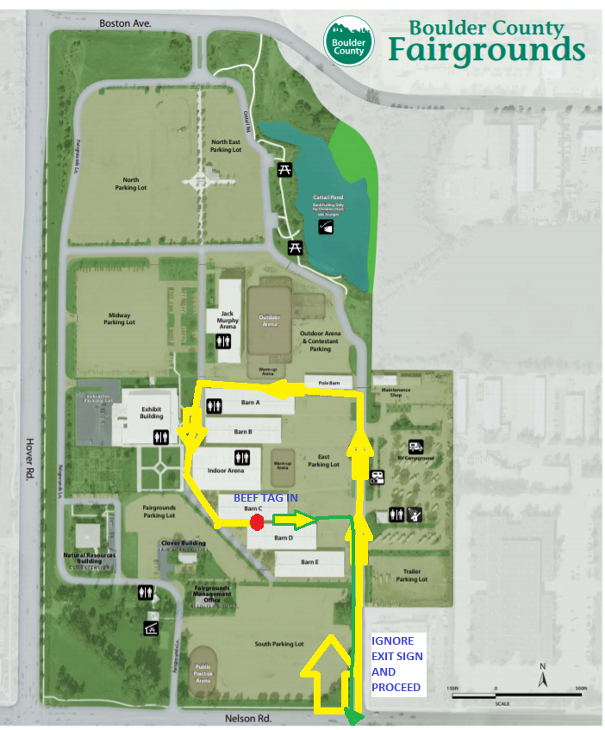
- Arrive at the fairgrounds following the attached map for traffic route.
- Stay in your vehicle until we come to you and it is your time. We are requesting only the beef member(s) and one adult helper per family will be allowed in the scale area according to keeping the numbers of 10 per area.
- All in attendance MUST WEAR Facial coverings/Masks per Boulder County Public Health.
- Ask for any paperwork you may not have completed and complete this in your vehicle.
- Pull your trailer to the south side of barn C. We will have panels to go to the back of the trailer.
- Unload your animal with halter to the scale chute.
- Turn in Brand Papers to the brand inspector.
- Pay your fees. $4 per animal (Exact cash appreciated)
- Turn in breed verification form, and state fair nomination form (Used for all Boulder County participants as well).
- Animal will be weighed.
- We will move calf to the second head catch where it will be tagged and retinal scanned.
- The 4-H member or Adult helper will then take animal out of the head catch and it can be tied to the railing. If you have other calves to unload, we will follow this process for the rest of the animals in the trailer.
- Once the trailer is empty, we will have you move the trailer to the EAST end of Barn C to load your animals back in.
- We ask once you are loaded that you leave the fairgrounds to the next family can participate in the tag in process. This process is so we can remain under 10 people at a time out of their vehicles.

