4-H Online 2.0 Enrollment tip sheet for families Boulder County 4-H
4-H Enrollment BOULDER COUNTY 2020
FAQ’s- The following notes help clarify areas you may need before starting the enrollment process.

- Fees remain at $40/ member - $120 per family maximum by early deadline
- Late fees added for re-enrolling members after deadline $60/member and $180 per family maximum.
- Shirt sizing: This is a standard feature of our enrollment system. All youth will not receive a shirt. However, select the size of the shirt you need. If you are filling out a youth enrollment it is youth sizing, if an adult enrollment it is adult sizing. The internal report will indicate for us if it is for Youth or Adult, according to type of enrollment). Use the box to indicate what adult size a youth may need in adult sizing if necessary.
- There is an option to select “junior leader” for the enrollment, however we do not offer this in Boulder County at this time.
- Uploads: you will find the system has places for these uploads, but may not be required in Boulder
  - Photo (optional)
  - Shooting Sports Hunter ID Card- Required for those Shooting sports projects
  - 4-H County Manual Policies Upload - NOT Applicable in Boulder Co
  - Member/Volunteer File Upload – Not applicable in Boulder Co
  - Shooting Sports Completion Certificate – Adult/Volunteers please upload if you have them. Additional County Forms – Not applicable in Boulder Co
- Signatures: throughout the enrollment process there will be places for you to type your name. The description says “Manager Name Certifying Paper Consent” and this means it is the parent/guardian/manager of the youth or adult agreeing to the signature.
- Fees Paid- please leave this blank and do not check the box at this time.
- Leader/Adult Volunteer Enrollments: The enrollment process looks different. You will select the projects just like the kids select projects. It will not be designated as a leader project this year, but rather enrollment in a project.
  - The State will have more detailed step-by-step for Adults as they have additional details that are crucial in successfully re-enrolling.
  - Adult Profiles without birthdates: If for some reason you did not have a birthdate in our old 4Honline system, we will need to update this at the state level. Please let us know if you have challenges and we will work with you.

For more information and directions on the entire enrollment process, please visit our Boulder County 4-H Enrollment website:
https://boulder.extension.colostate.edu/4h/enrollment/

Specific directions for enrolling through 4Honline are on the following pages.

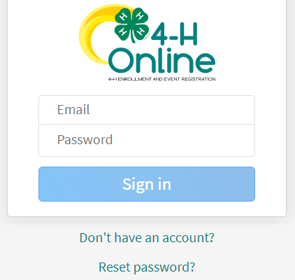
Logging in
After 14 years of using 4-H Online, Colorado 4-H is transitioning to version 2.0 (mobile friendly) for the 2020-2021 4-H enrollment year! Things are going to look very different and we thank you for your patience during this transition time as many features are still underway.

- To get started, go to our URL: co.4honline.com
- DO NOT USE INTERNET EXPLORER AS IT IS NOT SUPPORTED

4-H families that are re-enrolling
- Enter the email address and password that you previously used in 4-H Online to "Sign in". (Click "Reset password" if your password is not working)
- 4HOnline 2.0 has higher password standards, so it’s possible that your password is too short or requires additional security.

4-H families enrolling for the first time
- Be sure to contact your local county extension office prior to beginning your online enrollment.
- Click the link “Don’t have an account?”
- Select "Colorado" and then “Colorado 4-H Youth Development”.
- Select the county
- Enter your family’s contact information and set a password.
- Click "Create Account"
- Enter your family’s address information and click Verify.

Login troubleshooting
If you have previously created a 4-H Online account, 4-H Online will prevent you from creating a new account based on your email address, mailing address and/or phone number. This can sometimes be resolved with the on-screen prompts, other times staff assistance may be needed:
- Contact your local extension staff

Helpful hints: Look for the buttons!
Throughout the enrollment process, look for the Blue buttons to proceed, and ultimately, the Green button to ‘submit’.

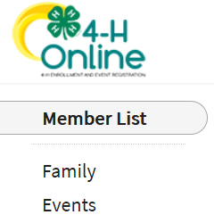
Re-enrolling previous 4-H youth members
- Click on "Member List" to see existing member records.
- Click “Enroll Now” for the member you're re-enrolling.
- Select the member’s current school Grade, click Next and then Enroll.
- Proceed through the next several screens to complete enrollment*.

Enrolling new 4-H youth members

Step 1 - create a Member Profile
- Click "Add Member"
- Click on the "4-H" program and then "Next"
- Enter the requested information on the next screens to create the new member's profile.
  - This profile will remain in place for all future enrollments and event registrations.
- Click on "I want to join 4-H as a New or Returning 4-H Member", then Finish

Step 2 - enroll in the current 4-H year
With the member's profile created, proceed through the next several screens to complete enrollment.*

* NOTE: Additional Information Tips for Enrolling
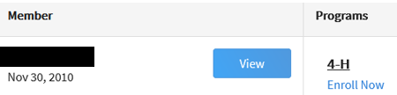
View – Allows the end-user to update the “Members” profile
Enroll Now – Allows member to begin the enrollment process answering questions such as:
Choosing a 4-H Units (Club) and Project – local extension staff should questions arise. Use the other “Blue” buttons to your advantage!
Tell Us About You and Share Information!
Share your health information isn’t required but helpful, if needed during
county, district, regional or state events. The only requirement are signatures to agree or disagree on emergency situations.
Required Consents for Members and Parents to Sign each 4-H Year (Code of Conduct, Participation, and Photo Release) – Only if a member takes an animal project the Animal Care and Housing Form is required per project.

Select that you will pay by check. However, we have a few options for payment and questions should be directed to your organizational leaders (see NEXT STEPS BELOW). NOTE: Always check with the county for all FEES, Some projects and clubs may have additional fees. EX: Shooting sports fee $20 and Dog Fee is $20 and are made payable to their respective 4-H Council budgets.

What Next?
After you submit enrollments/re-enrollment, you will receive an email from the 4-H Online server as a confirmation and with more information about participating in 4-H.

- Make Payment of your enrollment fees!
  - If you would like to make payments online we have setup an eventbrite link https://4h-enrollment-2020-21.eventbrite.com
    - In order for this to work, families will need to “print their ticket” showing they have paid for their enrollment. The ticket will then need to be emailed or given to your club leader showing proof of online payment. (Screenshots work too.)
  - Pay by check or cash? Work with your 4-H leader to make payments by checks or cash. Some groups are working towards meeting in person (small groups and approval required), but each leader will need to provide directions on collecting payments.
- In the days following your submissions the following will happen
  - Once payment is received from your club at the extension office, you will receive and email that says Enrollment Approved – Yay!
  - Enrollment Sent Back to Member – The County needs some corrections, then you would resubmit for review.
- Curriculum for your projects: Purchasing curriculum will be through your organizational leader this year and payment will need to be made to your 4-H Club. The order form can be found here: Self Calculating Publication Order Form
- NOTE: Animal Entry Information will be coming soon! Stay tuned!

For more information and directions on the entire enrollment process, please visit our Boulder County 4-H Enrollment website:
https://boulder.extension.colostate.edu/4h/enrollment/

Important Dates:
The following schedule has been developed to help our 4-H Program provide better support to the members and families:
- Last Friday in January (January 29, 2021) – re-enrollment for all returning members. Returning members need to be enrolled in 4HOnline and money received by the organizational leaders and then received by the Extension Office.
- January 30, 2021 – Last Friday in April (April 30, 2021) – $20.00 late fee will be applied for returning member re-enrollments
- Last Friday in April (April 30, 2021) – Deadline for project add/drop and the final day to enroll in 4-H and be eligible to participate in the 2021 Boulder County Fair.

Questions?
Ask your organizational leader first as they will most likely be able to respond faster than our office staff, however we are here to assist.

Audra Harders aharders@bouldercounty.org
Lisa Wallace lwallace@bouldercounty.org
Faith Kroschel fkroschel@bouldercounty.org
Brenda Kwang bkwang@bouldercounty.org

