4-H Online 2.0 Volunteer Renewal Guide

**Boulder County 4-H**

4-H Enrollment BOULDER COUNTY 2020

FAQ’s- The following notes help clarify areas you may need before starting the enrollment process.

1. Shirt sizing: This is a standard feature of our enrollment system. All adults will not receive a shirt. However, select the size of the shirt you need. If you are filling out a youth enrollment it is youth sizing, if an adult enrollment it is adult sizing. The internal report will indicate for us if it is for Youth or Adult, according to type of enrollment).
2. Uploads: you will find the system has places for these uploads, but may not be required in Boulder
   1. Photo (optional)
   2. Shooting Sports Hunter ID Card- Required for those Shooting sports projects
   3. 4-H County Manual Policies Upload - *NOT Applicable in Boulder Co*
   4. Member/Volunteer File Upload – *Not applicable in Boulder Co*
   5. Shooting Sports Completion Certificate – Adult/Volunteers please upload if you have them. Additional County Forms – *Not applicable in Boulder Co*
3. Signatures: throughout the enrollment process there will be places for you to type your name. The description says “Manager Name Certifying Paper Consent” and this means it is the parent/guardian/manager of the youth or adult agreeing to the signature.
4. Fees Paid- please leave this blank and do not check the box at this time.
   1. **Adult Profiles without birthdates:** If for some reason you did not have a birthdate in our old 4Honline system, we will need to update this prior to enrollment. (Your error message will say you don’t meet the age requirements.) See step #3 Below in the directions to fix this. Graphical user interface, text, application, email

      Description automatically generated
5. Units- you may see this term used instead of clubs or groups. The National organization changed the use of the word “Clubs” to “Units”. We use clubs in Boulder County, but know that when searching for club information it will be under the units steps. CLUB = UNITS

For more information and directions on the entire enrollment process, please visit our Boulder County 4-H Enrollment website:

<https://boulder.extension.colostate.edu/4h/enrollment/>

# New Enrollment

Join over 11,000 adults committed to youth across Colorado by joining the Colorado 4-H youth development program! How do you become a 4-H leader? [**Contact your county office**](http://extension.colostate.edu/staff-directory/?cn-s=&cn-cat=113/) to learn more! The safety of 4-H members is paramount. You will be asked to fill out an application and undergo a national background and motor vehicle check in order to become a volunteer. [Volunteer Resources](http://co4h.colostate.edu/volunteer-resources/) can be found on the [Colorado 4-H](http://co4h.colostate.edu/) website as well.

# Re-enrollments

*Colorado 4-H is transitioning to version 2.0 (mobile friendly) for the 2020-2021 4-H enrollment year! Things are going to look very different and we thank you for your patience during this transition time as many features are still underway*.

Go to the URL and Log into [co.4honline.com](http://v2.4honline.com/).

DO NOT USE INTERNET EXPLORER AS IT IS NOT SUPPORTED

1. Enter the **email address and password** you used previously, then click “Sign in.”  
   1. 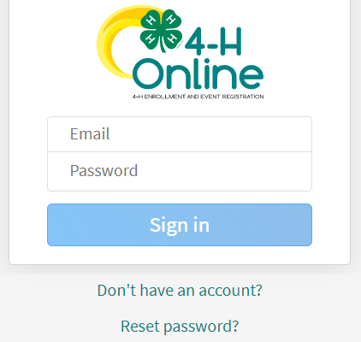Forgot your password? Scroll below the “Sign in” button and click “Reset password.” A temporary password will be sent to the email address associated with your account. You will be prompted to change this to a permanent password.
   2. Not sure which email address you used? Contact your local staff to ask them to look it up.
   3. Problems with your password? 4HOnline 2.0 has higher password standards, so it’s possible that your password is too short or requires additional security. Contact your local staff.
2. Click on “Member List” to see a list of youth and adults in your family account.
3. **View** – Allows the end-user to update the “Volunteers” profile. **NEW to 2.0: Birthdate Required to Enroll**
4. Select your name, then click “**Enroll Now**.”
5. When you see “I’m confirming I want to enroll in 4-H as a Volunteer,” click “**Enroll.**”
6. Select **Volunteer Type(s)**. You may select 1 or more of the following 3 types (Be sure to check both club and Project to get project updates:
   1. Club – allows you to select a club.
      1. 4-H Club Adult Volunteer = a general volunteer in your club.
      2. 4-H Club Contact Leader = if you are the main leader of your club. (organizational leader)
   2. **Project** – allows you to select projects, especially useful if you help with this project at the county level or if you want to receive project-specific emails about this project. (please sign up for all of your projects)
7. **Select Units** (clubs or groups):
   1. This will only appear if you selected the Club volunteer type.
   2. Find club name and click “Add.”
   3. Click “Next.”
8. **Select Projects**
   1. This will only appear if you selected the Project volunteer type.
   2. Select whether you work on this project (or would like to) at the county or club level.
   3. Select the project and click “Add.”
   4. Click “Next” when finished adding projects.
9. **About You**
   1. Click “Show Questions.”
   2. Review data that is carried over and fill in any blank required fields.
   3. Click “Next” when done.
10. Review **Consents**. This is the same information that was on your original application as a new volunteer.
    1. Type your full name and click “Agree.”
    2. Click “Next.”
11. Click “**Submit**,” then “Confirm.”
    1. 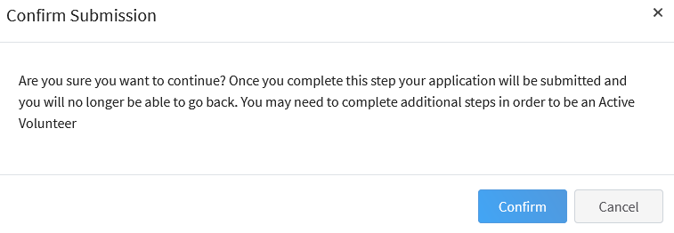You will receive an email confirmation that your enrollment has been submitted.
    2. Additional Information will be needed once the initial enrollment has been submitted.

# 

1. Click “Show Screening” – **REQUIRED to Re-enroll for this year ONLY!**
   1. Type ‘n/a’ under “Other Names”  
      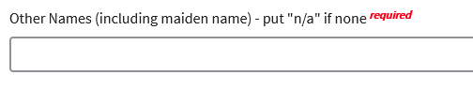
   2. Scroll to the bottom of the page and sign and agree with the statement ONLY.   
      Background checks will **ONLY** be completed on NEW volunteers or non-active status is greater 12 months. Click “**Submit**”  
      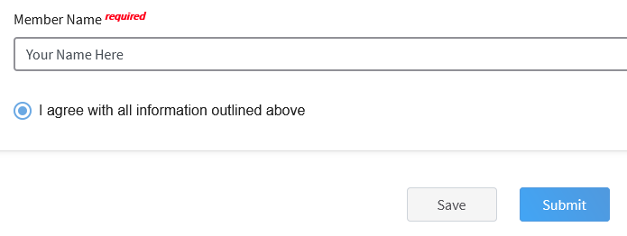
2. You will receive an email from 4-H Online with a confirmation. Please allows for several business days for final approval. Should you have any questions please contact your [local extension staff](https://extension.colostate.edu/staff-directory/?cn-s=&cn-cat=113) directly.

# Questions?

**Ask your organizational leader first as they will most likely be able to respond faster than our office staff, however we are here to assist.**

**Audra Harders** [**aharders@bouldercounty.org**](mailto:aharders@bouldercounty.org)

**Lisa Wallace** [**lwallace@bouldercounty.org**](mailto:lwallace@bouldercounty.org)

**Faith Kroschel** [**fkroschel@bouldercounty.org**](mailto:fkroschel@bouldercounty.org)

**Brenda Kwang** [**bkwang@bouldercounty.org**](mailto:bkwang@bouldercounty.org)