TIPS SHEETS:
Family entry Process:
http://co4h.colostate.edu/fairentry/documents/manage/family-helpsheet.pdf

Videos:
How to make an unlisted Youtube Channel See Video tip Sheet Here https://boulder.extension.colostate.edu/wp-content/uploads/sites/7/2020/07/How-to-Make-Videos-Shareable-YouTube-Information.docx

Entry Process
----------------
- Go to https://fairentry.com/Public/FindYourFair
- Enter your animals based on guidance about each species- You can find information in this document and at these two links:
  - Premium Book – Covid Edition https://boulder.extension.colostate.edu/wp-content/uploads/sites/7/2020/07/2020-4-H-Livestock-Fairbook-COVID-EDITION-7.7.2020-1.pdf
  - Virtual Show Entry Process for each species below:

- Submit your entries! Then the office will approve. (Be sure to submit all of your family members entries at the same time.)
  - The system will lock you out until the Extension office approves your entries. This may take a day or two, so be sure to plan ahead.
- Once you have entered, the photos will stay, however if you need to change videos, you can do so up until the deadline.
- Follow the guidance below for pictures and video.

All Animals
- Animals should be cleaned and groomed for a show.
- Please check fair book for rules and grooming requirements.
- Exhibitors should wear show clothes and follow the 4-H Dress Code.
DOG – Please see Fair Premium Book and below
CAVY- will be in person
UTILITY GOAT: Use standard example
DAIRY GOAT: Use standard example
FIBER GOAT: Use standard example
SHEEP: Use standard example
RABBIT: not needed- will do zoom showmanship
DAIRY CATTLE: In Person /standard for online backup
ALPACA/LLAMA: Video- See fair premium book
SWINE: see below and standard example
BEEF: Use standard example and directions below
POULTRY: See below- updated 7.20
HORSE: See Below – virtual – all videos
MARKET and BREEDING GOAT: See below
ALL LIVESTOCK AND MARKET ANIMALS (Standard Example):
1. Conformation Classes
A. Animals should be photographed from the front, rear/topline, and left and right sides (for profile view), and picture of member with ear tag in photo. (Upload 5 photos) These formats are accepted: .jpg, .gif, .png or .tif
B. Upload one video for each animal, the exhibitor should be handling the animal.

Video Requirements & Tips
- Video should be recorded on a phone held in landscape mode (horizontal)
- Video should be uploaded to YouTube, then copy the URL to your livestock entry. See Video tip Sheet Here https://boulder.extension.colostate.edu/wp-content/uploads/sites/7/2020/07/How-to-Make-Videos-Shareable-YouTube-Information.docx
- Video length should be up to 2 minutes long
- Showmanship interview videos will be up to 1 minute. Upload video with sound off, unless
    - The focus should be on the animal, however somewhere in the video you must include a shot of the exhibitor’s face with the animal.
    - The camera is the judge, so plan to show respecting the angle of the camera
    - If your animal is identified by an ear tag make sure the ear tag is clearly visible in a picture or video.

Video Example Guidelines:
- 15 sec-nose to tail side profile of animal standing
- 15 sec-animal walking towards camera
- 15 sec-animal walking side profile
- 15 sec-rear profile of animal walking away
- The camera is the judge, so plan to show respecting the angle of the camera. Make sure the ear tag is clearly visible in a picture or video.

2. Showmanship - For showmanship, refer to your specific species for instructions
A. Provide a up to 1 minute video of an interview-
- Introduce yourself, tell about your animal, what do you feed it, what is your daily care of your animal and anything else you would like to tell us about your project to demonstrate your knowledge. (plus species specific guidelines.)
B. Provide a up to 2 minute video of you showing your animal.

SWINE

Swine will be shown virtually this year, however we will be bringing animals to the fairgrounds to verify weights and classifications.

This year the Boulder County Fair Swine Barn will be hosting a VIRTUAL SWINE SHOW! Below you will ﬁnd the process for entering your project into fair (same as last year), and the additional process of showcasing and submitting your Swine project for judging.
STEP 1
Enter your project into Fair Entry, be sure to select all categories that you wish to be entered in. We will hold shows for MARKET, BREEDING, SHOWMANSHIP, and OWNED & BRED.
Make sure to double check your entries prior to the entry deadline so you do not miss out on a show!!
STEP 2
Prepare 4 photos and 1 video for each animal entered. You may use the same (or create a new video) for each animal even if you enter them into multiple categories.
However you must have separate videos and photos for each speciﬁc animal.
Showmanship:
Create and upload an additional 1min.(max) video for the interview portion. Please elaborate on the following topics in your interview:
- ~What do you like about your hog? What would you change if you could?
- ~Explain any speciﬁc challenges you encountered this this hog?
Senior Level Exhibitors:
- ~Did you have any speciﬁc feed challenges for this hog? Did you learn any new skill when raising this hog?
- ~Talk more in depth about the structure and build of your hog. Get more speciﬁc about what you would change about your hogs build.
The deadline for video and photo uploads is JULY 27, 2020.
Videos may be edited up until that date.
WEIGHT VERIFICATION:
We will assign your time to bring your pigs to the fairgrounds for weight verification and classification. Dates for weight verification are July 29th and July 30th. If your family is experiencing COVID related health concerns and unable to attend in person weight verifications, please contact the superintendent prior to entry deadline to determine the process for verifying your weights.

JUDGING:
Once weights are verified, we will divide the animals into weight classes. The weight/breed classes will be then divided on FairEntry. Your photos and videos will be divided in classes will be passed along to the judge.
Results will be posted and shared as soon as possible.

Horse – All virtual Show
Deadline for uploading videos and registering is August 3, 2020
- Patterns for the classes can be found here: HORSE INFORMATION PAGE https://boulder.extension.colostate.edu/additional-information-horse/
- Please follow the patterns for each class.
  - Watch for where the camera is noted and cone placement.
  - Take videos for the classes.
- We have scheduled times for the Indoor arena on Friday, July 29th and Saturday, July 30th for those who do not have access to their own arena. Sign up for your family time here : SIGN UP GENIUS: https://www.signupgenius.com/go/60B0F44ADAD2CA64-indoor
  - Please note that you must do this as an individual family and no more than 10 people can be in the indoor at a time. If you arrive early you need to wait at your vehicle until the person in front of you has left. Please be respectful and leave on time so others can use the arena.
- Check out these videos as examples:
  - How to film a rail class: https://www.youtube.com/watch?v=opKoBdFecF8&list=WL&index=2&t=0s
  - How to film a showmanship class: https://www.youtube.com/watch?v=W02kBApIWrU&list=WL&index=3
  - How to film a riding pattern: https://www.youtube.com/watch?v=eidCsaDiLhU&list=WL&index=2
- UPLOAD your videos to an online platform and get a url (link)
  - See ideas and examples/tip sheets here: * Tips on how to make videos shareable
- When you register through Fair Entry you should have your videos ready to upload at that time.
- Complete all of your family’s entries at the same time! Do not submit until all entries are included as the system will lock you out until your entries are approved. It will take the office a day or so to approve your entry. If it is near the deadline, you may miss the chance to enter your other classes.

POULTRY
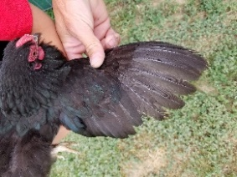
- Two photos submitted for Poultry Show Birds. Submit one side view photo of your bird posed, taken in a cage with door open or on a table and one photo of the from the top of the bird with one wing expanded. Example: https://cdn0.wideopenpets.com/wp-content/uploads/2017/10/Screen-Shot-2017-10-18-at-12.27.28-AM.png
- Showmanship: Junior Provide a 2-minute video of you showing your bird. Intermediate/Senior provide 4-minute video of you showing your bird. Please tell us your show number, introduce yourself, tell about your bird by identifying age-sex-breed, give breed history from American Standard of Perfection, explain health care, nutritional needs, what is your daily care of your animal, proper handling of the bird, do a proper examination of the bird from head, back, tail, feet, underside, while naming parts, and strengths and weaknesses of breed characteristics. If you have time you may add anything else, you would like to tell us about your project to demonstrate your knowledge. Must be in showmanship attire long pants, shirt with collar, and closed toed shoes. Though there is a lot of information, please keep it within the required time frames as to make it a fair competition. May be slightly over or under but stay as close to the time frame as possible. Example: https://www.youtube.com/watch?v=ydroCeHdXJo
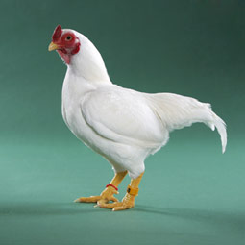
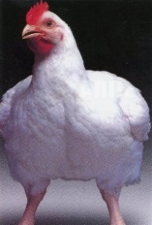
- Market Chickens: Market Chickens will be an in-person event on Wednesday August 5th. In the morning there will be a check in by appointment (time TBD), barn will be cleared out, chickens weighed, and then judged. In the evening there will be appointment check outs. We will be cautious of the 10-person limit in the barn, so please make sure you are on time for each of your appointments. In case we cannot have in person Market Chickens: Two photos need to be submitted through Fair Entry ahead of time for backup. One photo of your chicken standing breast forward. The other of your chickens from a side profile. This does not have to be perfect. Main concept is to see their breast if possible and be able to tell their health. No need to wash any chickens, currently I know your market pens are very sensitive to the heat and any changes. Just make it nice and easy and set them on the ground if need be and take the photo for entry. Examples on right:
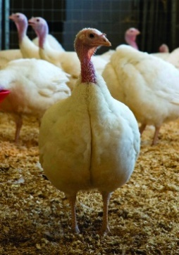
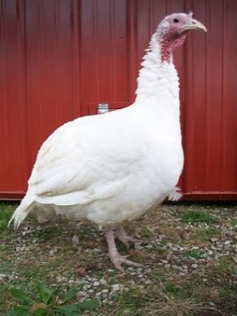
- Market Turkeys: Market Turkeys will be an in-person event on Wednesday August 5th. In the morning there will be a check in by appointment (time TBD), barn will be cleared out, turkeys weighed, and then judged. In the evening there will be appointment check outs. We will be cautious of the 10-person limit in the barn, so please make sure you are on time for each of your appointments. In case we cannot have in person Market Turkeys: Two photos need to be submitted through Fair Entry ahead of time for backup. One of your turkeys standing facing forward with breast forward. The other of your turkey with a side profile. This does not have to be perfect. Main concept is to see the breast if possible and be able to see their sex and if tell their health. No need to wash them, keep it simple and just take photos on the ground if need be for photo entry. Examples:

- Egg Production Pens: Egg Production will be an in-person event on Wednesday August 5th. In the morning there will be a check in by appointment (time TBD), barn will be cleared out, and then judged. Please remember to have your Egg Productions Records done even though record books are not required to be completed this year. This is what we use for any tie breakers. In the evening there will be appointment check outs. We will be cautious of the 10-person limit in the barn, so please make sure you are on time for each of your appointments. In case we cannot have in person Egg Production: Two photos need to be submitted through Fair Entry ahead of time for backup. Same two photos as Show Birds, please see above.

- Photo Contest: Each 4-H member may enter up to two photos of any poultry related photo. The photo must be taken by the poultry member. Please enter based on your 4-H age.

- Poultry Costume Contest: Please enter one photo of you and your bird in costume with a brief description of your group costume. Keep costumes within dress code requirements and make sure they are safe for your bird. One entry per member please.

- Egg Judging Contest: Please enter two photos. One showing three uniform eggs cleaned and side by side. Example: https://www.raising-happy-chickens.com/images/leghorn-eggs.jpg One showing ONLY ONE of those same eggs broken open on a plate with a clear view of the entire egg. A white paper plate works great for this. Example: https://www.youtube.com/watch?v=bE0qDjd_XAA.

MARKET AND BREEDING GOAT SHOW:
2020 Boulder County Market and Breeding Goat Virtual Show
This is a five step process. The first step involves setting up your show ring. The second step is completing the show pattern. The third step is completing a showmanship video. Step 4 requires that you submit pictures of your project. Step 5 involves uploading your pictures and videos to FairEntry.

Step 1—Show Ring Set Up: You will need to set up a show ring that has 7 cones or items to mark each point in the patter. All cones are set 10 feet apart.
- There are seven (7) cones: A, B, C, D, E, F, and G. Cone E is the Judge cone. The person who is films should stand about 2-3 feet to the right and back of cone E. See figure below.
- Notice that cone E (judge) is set to the right of cone D. This is important for both showmanship and market classes. When showing your goat, treat cone E as the Judge. So make eye contact with the camera and use cone E as if it was your judge.

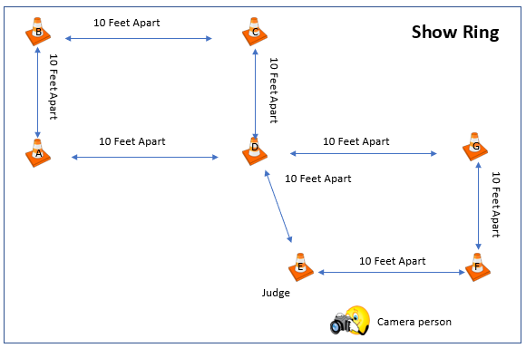

Step 2—Show Pattern: Now that you have your show ring set up. You will have two patterns to complete.
- Pattern 1: You will start your pattern at cone A. You will be facing away from the judge. See figure below and the pattern is in blue arrows. In a counter clockwise direction, walk from cone A to B to C to D and face the judge. Pause for 10 seconds. Notice your judge will be on your left at cone E.
- Pattern 2: In a counter clockwise direction, walk form cone D to E to F to G and back to D. At cone D face away from the judge, set up your goat, and brace your goat for at least 10 seconds. If you are showing a breeding doe or nanny, you do not need to brace. See figure below and this pattern is in orange arrows.
- End the video. The video can be no longer than 2 minutes (120 seconds).

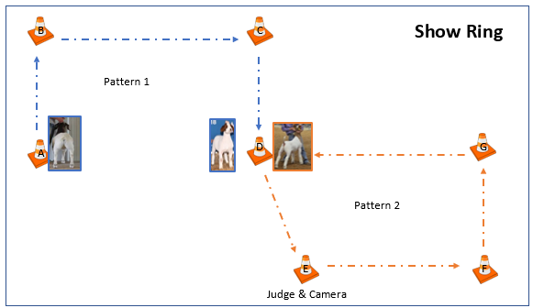

YouTube Tutorial 1: https://youtu.be/UPpuTl-iqI4
YouTube Tutorial 2: https://youtu.be/GAXr0n3OeN8

Step 4—Showmanship Video: For showmanship, you will need to take a 1-minute (60 seconds) interview.
- Please introduce yourself. Include your name, 4-H club, and your project.
- Next, describe your project.

Step 4—Profile Pictures: You will need to take pictures of your market and breeding goat.
- You need a front facing picture.
- You need a rear facing picture.
- You need a right facing picture.
- You need a left facing picture.
- You need a picture that captures the topline of the goat.
- For market class, you will also need to take a picture of your goat on a scale where the weight is clearly visible.

Step 5—Submitting Your Video and Pictures:
- Go to https://fairentry.com/Public/FindYourFair
- Enter your animals based on guidance from your superintendent. (We will need to reach out to the kids and let them know if we are limiting # of animals, # of classes, etc.)
- Submit your entries by July 27th, 2020. Then the office will approve. NOTE: You must do ALL of your family’s entries at the same time BEFORE you submit. They system will lock you out until we approve them.
- Once you have entered, the photos will stay, however if you need to change videos, you can do so up until the deadline of July 27th, 2020.
- Follow the guidance below for pictures and video.

All Animals
- Animals should be cleaned and groomed for a show.
- Please check fair book for rules and grooming requirements.
- Exhibitors should wear show clothes.
- All exhibitors must practice social distancing.
- Only 1 parent or guardian can accompany the exhibitor during the show.
- All exhibitors and guests must wear face masks.

DOGS – VIDEO ENTRIES FOR FAIR
In the event the in-person County Fair 4-H Dog Show is cancelled due to the virus, video entries may be considered for project completion and State Fair eligibility. Members who are interested in competing at State Fair should upload video entries to Fair Entry for each of their classes. Video entries may be filmed at a 4-H Virtual Fun Match, at home or at another training event. There will also be a “last minute” opportunity for members to “Reserve-A-Ring” to film their video entries. Reserve-a-Ring will be available in the Barn A Outdoor Arena on Monday July 27th. Sign up in advance at this link https://www.signupgenius.com/go/904044BAAA722A7FB6-boulder Video entries will be judged ONLY if the in-person 4-H Dog Show is cancelled prior to the contest. Directions for uploading videos will be provided by the Extension Office and will generally require uploading to a private YouTube account and then pasting the URL into Fair Entry.
Ring Procedures and Patterns for Obedience, Rally and Showmanship, along with filming directions, can be found at https://drive.google.com/drive/folders/1755cjLPQZUvVi3wZDZsPPj8TPkrOTY2Q?usp=sharing
The deadline for all Fair entries, including videos is Monday, August 3rd.

MARKET AND BREEDING BEEF

For Showmanship: If you choose to enter showmanship you will enter 1 more video:
- Please introduce yourself. Include your name, 4-H club, and your project.
- Next, describe your project.
Submitting Your Video and Pictures:
- Go to https://fairentry.com/Public/FindYourFair
- Enter your animals based on guidance from your superintendent.
- Submit your entries by July 27th, 2020. Then the office will approve. NOTE: You must do ALL of your family’s entries at the same time BEFORE you submit. They system will lock you out until we approve them.
- Follow the guidance below for pictures and video.
All Animals
- Animals should be cleaned and groomed for a show.
- Please check fair book for rules and grooming requirements.
- Exhibitors should wear show clothes.

