MARKET AND BREEDING SHEEP SHOW:
2020 Boulder County Market and Breeding Sheep Show

In the event the in-person County Fair Sheep Show is cancelled due to the virus, video entries will be considered for project completion, so it is required all entries have the virtual parts.
Similarly exhibitors may choose to participate virtually and also complete their project. We will have a separate class for Virtual Only Entries for all Market Lambs. Virtual only entries in market lambs will be placed separately. Members should enter the virtual only classes if you do not plan to come to the fairgrounds. Virtual only animals are not eligible for the Grand champion drive.

Breeding Sheep Entries will all be done virtually this year.

The following guide is intended to provide directions for virtual project submission.

Step 1—Show Ring Set Up: You will need to set up a show ring that has 7 points, (use cones, bean bags or common safe items to mark each point in the pattern. There are seven (7) cones: A, B, C, D, E, F, and G. Cone E is the Judge cone. The person who is films should stand about 2-3 feet to the right and back of cone E. See figure below.
- Notice that cone E (judge) is set to the right of cone D. This is important for both showmanship and market classes. When showing your lamb, treat cone E as the Judge. So make eye contact with the camera and use cone E as if it was your judge.

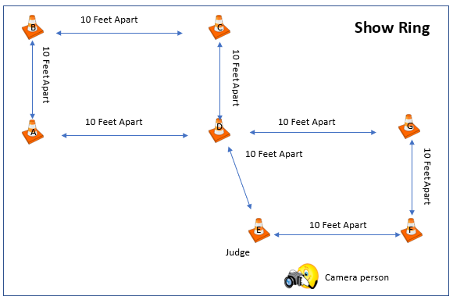
Step 2—Show Pattern: Now that you have your show ring set up. You will have two patterns to complete.
- Pattern 1: You will start your pattern at cone A. You will be facing away from the judge. See figure below and the pattern is in blue arrows. In a clockwise direction, walk from cone A to B to C to D and face the judge. Pause for 10 seconds. Notice your judge will be on your left at cone E.
- Pattern 2: In a counter clockwise direction, walk form cone D to E to F to G and back to D. At cone D face away from the judge, set up your lamb, and brace your lamb for at least 10 seconds. If you are showing a breeding sheep, you do not need to brace. See figure below and this pattern is in orange arrows.
- End the video. The video can be no longer than 2 minutes (120 seconds).

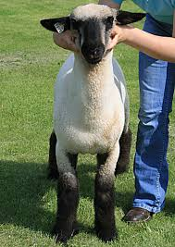
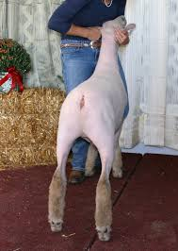
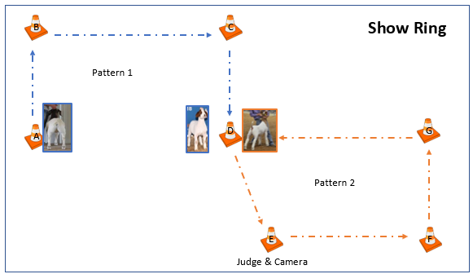

Step 3—Showmanship Video: For showmanship, you will need to take a 1-minute (60 seconds) interview.
- Please introduce yourself. Include your name, 4-H club, and your project.
- Next, describe your project.

Step 4—Profile Pictures: You will need to take pictures of your market and breeding sheep.
- You need a front facing picture.
- You need a rear/topline picture of the sheep.
- You need a right facing picture.
- You need a left facing picture.
- You need a picture that shows the exhibitor and the animal with the ear tag visible.

Step 5—Submitting Your Video and Pictures:
- Go to https://fairentry.com/Public/FindYourFair
- Enter your animals based on guidance from your superintendent.
- Submit your entries by July 27th, 2020. Then the office will approve. NOTE: You must do ALL of your family’s entries at the same time BEFORE you submit. They system will lock you out until we approve them.
- Once you have entered, the photos will stay, however if you need to change videos, you can do so up until the deadline of July 27th, 2020.
- Follow the guidance below for pictures and video.

All Animals
- Animals should be cleaned and groomed for a show.
- Please check fair book for rules and grooming requirements.
- Exhibitors should wear show clothes.

Reminder for the In-Person Show

- All exhibitors must practice social distancing.
- Parents and/or guardians must stay at the trailer/car while the exhibitor shows in the indoor arena. (this was to allow us to actually be able to operate the show in person. We will have experienced helpers available in the show ring to assist if an animal escapes.)
- All exhibitors and guests must wear face masks while on the fairgrounds.

MARKET SHEEP SHOW IN PERSON:
2020 Boulder County Fair Market sheep show in person process of show.

2020 Boulder County Market Sheep Jackpot Style Show
This option will be conducted on the Boulder County Fairgrounds, on Thursday, August 6th from 8:00 a.m. to 3:00p.m. It will be conducted in the Indoor Arena and staged in Barn C. See figure below.

Here is the process to the face-to-face show.
- You will first weigh your lamb in Barn A to determine the weight classes. This will be done in waves of 3 to 4 exhibitors at a time with 1 accompanying parent. We will be live streaming the show so that your family and friends may watch it online. We will have a sign up for slots and will be using a free text messaging service to communicate when we are ready for you to come and weigh your goat. Once you weigh you will go back to your trailer and wait. No stalls available.
- We will start with Junior Showmanship class. As we could have 9 juniors, we will have two heats of this class. The 1st and 2nd place winners of each heat will then compete in a champion drive. Once you are done with this class, you will return to your trailer. Only youth will be allowed in the indoor arena. Parents/guardians must watch virtually from their trailers/cars.
- Next, we will have the Intermediate Showmanship Class. There are potentially 15 Intermediate Exhibitors. Thus we will have three heats for this category. The 1st and 2nd place winners of each heat will then compete in a champion drive. Again, parents and guardians must watch virtually from their trailers/cars. Once you are done with this class, you will return to your trailer.
- Next we will have the Senior Showmanship Class. There are potentially 14 Senior Exhibitors thus we will have 2 heats. Similar to the Intermediate category, we will have the 1st place and 2nd place exhibitors compete in a championship class. Again, parents and guardians must watch virtually from their trailers/cars. Once you are done with this class, you will return to your trailer.
- Depending on the weights of each market lamb we will divide classes while showmanship is happening. Classes will be per breed, Dorset, Southdown, speckled face, blackface, all other breeds. After the classes have been judged there will be a champion drive. Depending on numbers in each area, we will only bring in 1st place animals in the champion ring. Then once the champion is picked, we will bring in the second place from the champion’s class to compete for the reserve champion. Once you are done with this class, you will return to your trailer.
- All market lambs will need to be show ready by the time they come to the fairgrounds. There will be no opportunity nor time to wash, clip, or prepare your lamb on the grounds. There will be no access to electricity, water, stalls, etc.
- Results of the showmanship and market classes will be announced at the time of the show.
- If you are not actively showing, your lambs need to remain in the trailer, and you may not be in the Indoor Arena or Barn C or other places on the fairgrounds.
- If the weather is too hot for keeping the lambs in trailers and you have concerns, please contact show management. We will do our best to find a place to social distance and allow shade for your animals. You will need to sit or stand with your lambs on a halter when given your location. It is important to social distance and not interact with other groups of people than your immediate family. There will be schedule for exhibitors to bring their lambs in to the show. Only 10 People will be allowed in Barn C.
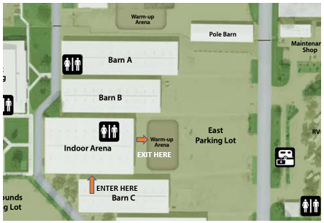
- Exhibitors will enter the Indoor Arena from the south central door when they have been instructed to do so, and will exit on the east central door and return to their trailer. See diagram below.
- It is important that everyone attending and participating follow our guidelines of the show, public health and participation on the fairgrounds. It is important that families stay in their immediate family groups, and no socializing. While you are on the grounds it is important to wear facial coverings and stay at least 6 feet apart and groups of 10 or less. The success of the sheep show, and all of the Boulder County Fair, rides on the understanding that each family member, participant and volunteer does their part to follow the rules and guidelines. Please help make this a successful event.

