2020 Boulder County Fair
Procedures for Market and Breeding Goat Show

Hello, members! To say the least this has been a wild past several months. We will be having two options for our 2020 Boulder County Fair Market and Breeding Goat Show. Option 1 is an in-person show that is limited to 10 people practicing social distancing and other safety measures. Option 2 is that you can show your market, showmanship, or breeding classes via an online show. For both options, all exhibitors will be judged in the same class. For example, if you are senior and you elect to do the virtual Senior Showmanship Class, your video and pictures will be shown to the judge during the face-to-face Senior Showmanship Class and you will placed in that class.

Option 1: 2020 Boulder County Market and Breeding Jackpot Style Show
This option will be conducted on the Boulder County Fairgrounds, on Wednesday, August 5th from 12:00 p.m. to 6:00p.m. It will be conducted in the Indoor Arena and staged in Barn C. See figure below.

Here is the process to the face-to-face show.
- You will first weigh your goat in Barn A to determine the weight classes. This will be done in waves of 3 to 4 exhibitors at a time with 1 accompanying parent. We will be live streaming the show so that your family and friends may watch it online. We will have a sign up for slots and will be using a free text messaging service to communicate when we are ready for you to come and weigh your goat. Once you weigh you will go back to your trailer and wait. No stalls available.
- We will start with Junior Showmanship class. As we only have 3 juniors, we will only have one heat of this class. Once you are done with this class, you will return to your trailer.
- Next, we will have the Intermediate Showmanship Class. There are potentially 6 Intermediate Exhibitors. Thus we will have two heats with 3 members in each heat for this category. The 1st and 2nd place winners of each heat will then compete in a champion drive. Again, each exhibitor can bring one parent or guardian. Once you are done with this class, you will return to your trailer.
- Next we will have the Senior Showmanship Class. There are potentially 9 Senior Exhibitors thus we will have 3 heats. Similar to the Intermediate category, we will have the 1st place exhibitors compete in a championship class. Once you are done with this class, you will return to your trailer.
- Depending on the weights of each market goat, we will have 1-2 classes per lightweight, middle weight, heavy-weight, and local owned and bred divisions. Each division will have a champion and reserve champion. After the 4 divisions have been judged there will be a champion drive. Once you are done with this class, you will return to your trailer.
- For the breeding classes, will only have 2 exhibitors and will conduct each type of breeding class. Again, only 1 parent per exhibitor. Once each class has been judged, we will have a champion breeding drive for breeding doe. Once you are done with this class, you will return to your trailer.
- All market and breeding goats will need to be show ready by the time they come to the fairgrounds. There will be no opportunity nor time to wash, clip, or prepare your goat on the grounds.
- Results of the showmanship, market, and breeding classes will be both announced at the time and be sent out to all market and breeding goat members.
- If you are not actively showing, your goats need to remain in the trailer and you may not be in the Indoor Arena or Barn C.
- If the weather is too hot for keeping the goats in trailers we will social distance in Barn C. You will need to sit or stand with your goats on a leash or tether in Barn C. There will be schedule for exhibitors to bring their goats in then leave. Only 10 People will be allowed in Barn C.
- Exhibitors will enter the Indoor Arena from the south central door when they have been instructed to do so, and will exit on the east central door and return to their trailer. See diagram below.

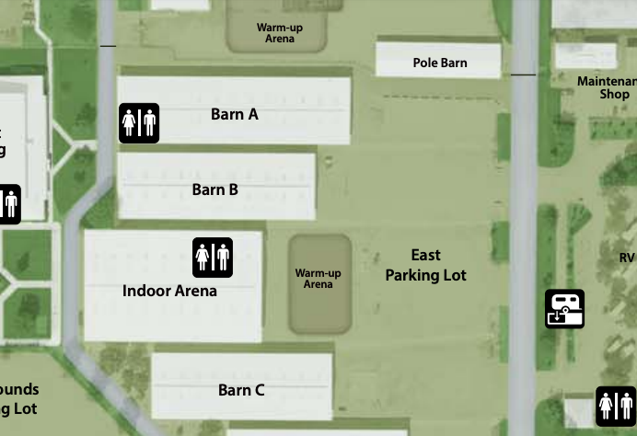
EXIT HERE
ENTER HERE

Option 2: 2020 Boulder County Market and Breeding Goat Virtual Show
This is a five step process. The first step involves setting up your show ring. The second step is completing the show pattern. The third step is completing a showmanship video. Step 4 requires that you submit pictures of your project. Step 5 involves uploading your pictures and videos to FairEntry.

Step 1—Show Ring Set Up: You will need to set up a show ring that has 7 cones or items to mark each point in the patter. All cones are set 10 feet apart.
- There are seven (7) cones: A, B, C, D, E, F, and G. Cone E is the Judge cone. The person who is films should stand about 2-3 feet to the right and back of cone E. See figure below.
- Notice that cone E (judge) is set to the right of cone D. This is important for both showmanship and market classes. When showing your goat, treat cone E as the Judge. So make eye contact with the camera and use cone E as if it was your judge.
Show Ring
Camera person
A
E
C
Judge
10 Feet Apart
10 Feet Apart
D
B
F
G
10 Feet Apart
10 Feet Apart
10 Feet Apart
10 Feet Apart
10 Feet Apart
10 Feet Apart

Step 2—Show Pattern: Now that you have your show ring set up. You will have two patterns to complete.
- Pattern 1: You will start your pattern at cone A. You will be facing away from the judge. See figure below and the pattern is in blue arrows. In a counter clockwise direction, walk from cone A to B to C to D and face the judge. Pause for 10 seconds. Notice your judge will be on your left at cone E.
- Pattern 2: In a counter clockwise direction, walk form cone D to E to F to G and back to D. At cone D face away from the judge, set up your goat, and brace your goat for at least 10 seconds. If you are showing a breeding doe or nanny, you do not need to brace. See figure below and this pattern is in orange arrows.
- End the video. The video can be no longer than 2 minutes (120 seconds).
Show Ring
Pattern 1
Pattern 2
A
E
C
Judge & Camera
D
B
F
G

YouTube Tutorial 1: https://youtu.be/UPpuTl-iqI4
YouTube Tutorial 2: https://youtu.be/GAXr0n3OeN8

Step 4—Showmanship Video: For showmanship, you will need to take a 1-minute (60 seconds) interview.
- Please introduce yourself. Include your name, 4-H club, and your project.
- Next, describe your project.

Step 4—Profile Pictures: You will need to take pictures of your market and breeding goat.
- You need a front facing picture.
- You need a rear facing picture.
- You need a right facing picture.
- You need a left facing picture.
- You need a picture that captures the topline of the goat.
- For market class, you will also need to take a picture of your goat on a scale where the weight is clearly visible.

Step 5—Submitting Your Video and Pictures:
- Go to https://fairentry.com/Public/FindYourFair
- Enter your animals based on guidance from your superintendent. (We will need to reach out to the kids and let them know if we are limiting # of animals, # of classes, etc.)
- Submit your entries by July 27th, 2020. Then the office will approve. NOTE: You must do ALL of your family’s entries at the same time BEFORE you submit. They system will lock you out until we approve them.
- Once you have entered, the photos will stay, however if you need to change videos, you can do so up until the deadline of July 27th, 2020.
- Follow the guidance below for pictures and video.

All Animals
- Animals should be cleaned and groomed for a show.
- Please check fair book for rules and grooming requirements.
- Exhibitors should wear show clothes.
- All exhibitors must practice social distancing.
- Only 1 parent or guardian can accompany the exhibitor during the show.
- All exhibitors and guests must wear face masks.

