2020 Boulder County Fair
Procedures for Market and Breeding Beef Show

To accommodate our show and meet the COVID restrictions set forth by the county, we will be having two options for our 2020 Boulder County Fair Market and Breeding Beef Show. Option 1 is an in-person event that is limited to 10 people practicing social distancing and other safety measures. Option 2 is that you can show your market or breeding classes via an online show. For both options, all exhibitors will be judged in the same class. For example, all angus steers will show against each other whether the entry is virtual, or you come to the fairgrounds. The Judge will have the virtual entries that do not come to the fairgrounds and place them accordingly just like they were present. All showmanship entries will be virtual.

Option 1: 2020 Boulder County Market and Breeding Jackpot Style Show
This option will be conducted on the Boulder County Fairgrounds, on Friday, August 7th from 9:00AM a.m. to 12pm for market and 1pm to 4pm for breeding. It will be conducted in Barn C. See figure below.

Process for the fairgrounds Market show.
- You will arrive at the fairgrounds at 9 am for the market show.
- You will wait in line to unload on the South side of Barn C. Once it’s your turn, your calf will be unloaded either by the exhibitor, or by our volunteers. Only the exhibitor is allowed out of the truck as we will need to maintain a 10 person limit.
- Once you have unloaded you will proceed to the EAST Parking Lot
- Your calf will go across the scale and your brand paper will be checked.
- Your calf will be tied in the SE quadrant of barn C according to his class.
- We will then call individual classes of exhibitors back to the barn c to present their animal one class at a time. In order to maintain our 10 person limit, only exhibitors will be allowed back in the barn. Parents and guardians will be asked to watch from the livestream and in your vehicles.
- We will have experienced cattle handlers to help kids maintain a safe environment with their animals.
- Once all the calves are in place, the judge will commence to sorting the classes, picking division champions and a Grand and Reserve Grand Champion.
- The judging will be livestreamed so you can watch from your vehicle.
- Once the selection of Grand has been completed, you will come to load out your steers, beginning with the grand Champion, then reserve, division champions and so forth.

Process for Breeding show
- You will arrive at the fairgrounds at 1pm for the breeding show
- You will wait in line to unload on the South side of Barn C. Please see figure below of how to arrive at fairgrounds. Once it’s your turn, your calf will be unloaded either by the exhibitor, or by our volunteers. Only the exhibitor is allowed out of the truck as we will need to maintain a 10 person limit.
- Once you have unloaded you will proceed to the EAST Parking Lot
- Registration Papers will be checked
- Your calf will be tied in the SE quadrant of barn C according to its class.
- We will then call individual classes of exhibitors back to the barn c to present their animal one class at a time. In order to maintain our 10 person limit, only exhibitors will be allowed back in the barn. Parents and guardians will be asked to watch from the livestream and in your vehicles.
- We will have experienced cattle handlers to help kids maintain a safe environment with their animals.
- Once all the calves are in place, the judge will commence to sorting the classes, picking division champions and a Grand and Reserve Grand Champion.
- The judging will be livestreamed so you can watch from your vehicle.
- Once the selection of Grand has been completed, you will come to load out your breeding animals beginning with the grand Champion, then reserve, division champions and so forth.

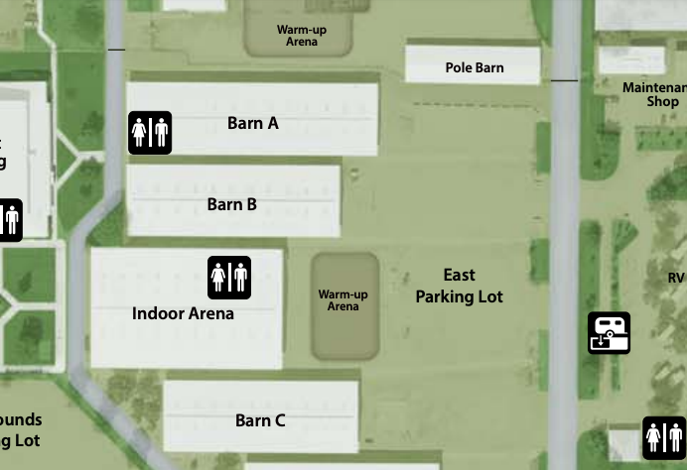
Route to Unload

Option 2: 2020 Boulder County Market and Breeding Beef Virtual Show
Every member will have to complete a virtual entry whether or not you plan to bring your livestock to the fairgrounds on Friday August 7th. When you enter at Fair Entry, you will upload 4 photos (front, back, each profile) as well as a 1 minute video of you walking your animal and setting them up.

For Showmanship: If you choose to enter showmanship you will enter 1 more video:
- Please introduce yourself. Include your name, 4-H club, and your project.
- Next, describe your project.
Submitting Your Video and Pictures:
- Go to https://fairentry.com/Public/FindYourFair
- Enter your animals based on guidance from your superintendent.
- Submit your entries by July 27th, 2020. Then the office will approve. NOTE: You must do ALL of your family’s entries at the same time BEFORE you submit. They system will lock you out until we approve them.
- Follow the guidance below for pictures and video.
All Animals
- Animals should be cleaned and groomed for a show.
- Please check fair book for rules and grooming requirements.
- Exhibitors should wear show clothes.

