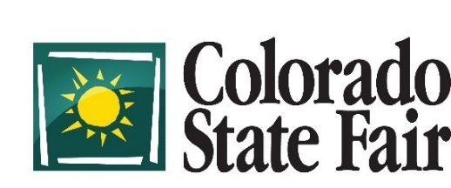
1001 Beulah Avenue, Pueblo, CO 81004

MARKET LAMB NOMINATIONS
Nominations must be to Extension Agents no later than June 1st
Nomination forms are due to CSF no later than June 8th
(1 SHEET PER EXHIBITOR) (Attach retinal scans)
THIS IS NOT AN ENTRY INTO THE COLORADO STATE FAIR – ENTRY FORMS DUE AUGUST 1ST

EXHIBITOR SHOWS AS: 4-H _____ FFA_____ MEMBER IN THE COUNTY OF:_______________

EXHIBITOR’S NAME:_______________________________ EXH. BIRTH DATE:___________________

MAILING ADDRESS:___________________________ CITY______________ STATE_______ ZIP________

HOME PHONE#:_______________ CELL PHONE#:_______________ E-MAIL:_________________

PREMISES ID:________________________________ _________________________________________
Location where animal raised and kept Address where animal raised and kept

NAME OF ANIMAL | BREED | SEX | CO. EAR TAG#

I hereby nominate the above Market Lamb(s) and agree to abide by the rules and regulations located in the Colorado State Fair Premium Book. THIS IS NOT AN ENTRY – ENTRIES FORMS WILL BE DUE AUGUST 1ST.

__________________________________________ ____________________________________
Exhibitor’s Signature Date Parent’s Signature (if minor) Date

I certify that this is the bona fide project of the named exhibitor and is eligible to be shown in accordance with the rules of this show and that the animal(s) nominated is/are owned by this Exhibitor. Exhibitor has completed all Meat Quality Assurance programs required by Colorado 4-H, Colorado FFA and the Colorado State Fair. I further certify the named Exhibitor is a resident of the State of Colorado as defined in the Jr. Livestock Competition Requirements.

__________________________________________ _____________________________
Extension Agent/Vo-Ag Instructor Signature Date

This Nomination Form must be filled out entirely and signed by the Exhibitor, Exhibitor’s parent if a minor and Extension Agent/Vo-Ag Instructor. Any form sent in by the Exhibitor will NOT be accepted. This Nomination Form is NOT AN ENTRY. For more information, contact the Livestock Office at 719-404-2035.

